Group Project Documentation
MICROSERVICES WITH SPRING BOOT

Kirenz Platform – Moments Social Network

Prepared by kirenz-social-media
Trần Hồ Thảo Nguyên

FPT Da Nang campus, 2026
Table of Contents

1. Project Introduction 1
1.1 Product Perspective 1
1.2 Project Objectives and Scope 1
1.3 User Classes and Characteristics 2
1.4. Business Rules 4
2. Database Design 5
2.1. Database strategy 5
2.2. Logical Data Model 6
2.3. Database diagram 7
2.4. Relationship Explanation 11
3. System Architecture (Microservices Architecture) 11
3.1. Operating Environment 11
3.2. Recommended Development Environment 12
3.3. High-level architecture 13
3.4. Service Responsibilities 13
3.5. Communication Design 14
3.6. Technology Learned and Applied 16
4. Implementation 17
4.1. Deployment Considerations 17
4.2. Screenshots and explanations 20
5. Conclusion 40

Revision History
Name | Date | Reason For Changes | Version
Vũ Hữu Nguyên Khôi | 15 Jun 2026 | Initial project structure and microservices architecture | 0.1
Vũ Hữu Nguyên Khôi | 20 Jun 2026 | Implement Identity Service, API Gateway, and Eureka Discovery | 0.2
Vũ Hữu Nguyên Khôi | 25 Jun 2026 | Add User Service, Social Service, Kafka event integration, and MongoDB | 0.3
Trần Hồ Thảo Nguyên | 30 Jun 2026 | Implement Chat Service, WebSocket, Notification Service, and Redis | 0.4
Trần Hồ Thảo Nguyên | 05 Jul 2026 | Complete frontend integration and core social features | 0.5
Trần Hồ Thảo Nguyên | 18 Jul 2026 | Final documentation review and project completion | 1.0
Project team | 11 Nov 2026 | Update LiveKit calling, administration, database design, deployment, and verification documentation. | 1.1

Project Introduction

Product Perspective
Kirenz Platform – Moments Social Network is a full-stack social networking system that enables people to create an account, build a personal profile, connect with friends, publish and discover content, communicate through real-time messaging and one-to-one video calls, and receive activity notifications. The project corresponds to the Social Media Blog Platform topic in the MSS301 group-project list and extends it with a friend graph, privacy controls, blocking, direct and group chat, LiveKit video calling, community reports, and administrative moderation.

The system is implemented as a single-page web application backed by independently deployable Spring Boot microservices. Kirenz separates authentication, user relationships, social content, chat, notifications, and administration into bounded services. An API Gateway provides one entry point for application APIs, Eureka supplies service discovery, OpenFeign supports synchronous service-to-service queries, and Apache Kafka distributes asynchronous domain events. PostgreSQL stores relational and transactional data, MongoDB stores social, chat, and call-session documents, and Redis supports temporary authentication data, presence, and call coordination. LiveKit provides managed audio and video transport. This architecture demonstrates the principal learning outcomes of the Microservices with Spring Boot course.

1.2 Project Objectives and Scope
The objectives of Kirenz are to:
1. Provide secure account registration, email verification, password login, Google login, access-token renewal, and protected API access.
2. Allow users to maintain a recognizable profile containing a display name, avatar, cover photo, biography, birth date, gender, location, and website.
3. Support a social graph through friend requests, friend lists, mutual friends, suggestions, unfriending, user blocking, and privacy preferences.
4. Support multimedia posts with configurable visibility, user tagging, sharing, comments, replies, and emoji reactions.
5. Help users discover people, post text, and hashtags through the Explore interface.
6. Provide direct and group chat with WebSocket delivery, attachments, typing indicators, online presence, nicknames, group administration, and read status.
7. Deliver in-app notifications for friend, social, report, and moderation events while maintaining read/unread state.
8. Support private one-to-one video calls with incoming/outgoing call controls, microphone and camera controls, and conversation history.
9. Allow users to report inappropriate posts or accounts and provide administrative tools for review, moderation, audit, and monitoring.
10. Demonstrate service isolation, database-per-service ownership, event-driven integration, fault tolerance, containerization, and a responsive React interface.

The current submission covers the responsive web application and its supporting backend, including one-to-one video calling, user-submitted reports, and an administrator interface for dashboard analytics, user management, report resolution, moderation, audit history, and service monitoring. Native mobile clients, public cloud production deployment, automated content moderation, advanced recommendation algorithms, and persisted notification-channel preferences remain outside the current user-facing scope. Video calling currently supports direct conversations between two users.

1.3 User Classes and Characteristics
Visitor
A visitor is a person who has not signed in. The visitor may browse the public feed, open a public post permalink shared by another person, create an account, verify an email address, sign in with an email/password pair, or use Google authentication. Only posts whose visibility is `PUBLIC` are returned by the anonymous API. Reactions, comments, discussion dialogs, profile access, reposting, and all private account functions require a valid JWT access token.

 | Function Name | Function Description
1 | Register an account | Create an account using display name, username, email, and password. The server validates uniqueness and request data.
2 | Verify email by OTP | Request and submit a one-time password delivered through email to prove ownership of the registered address.
3 | Login with email and password | Authenticate with credentials and receive access and refresh tokens
4 | Login with Google | Submit a Google identity token; the Identity Service verifies it and signs in or provisions the corresponding account
5 | Access public entry pages | View the login and registration pages. Protected pages redirect unauthenticated visitors to login.

Registered User
A registered user is the primary actor. The user is expected to access the platform from a modern desktop or mobile browser, may connect from any location or time zone, and may produce both private profile data and public or restricted social content.

 | Function Name | Function Description
1 | Manage profile | View and update display name, avatar, cover photo, biography, birth date, gender, location, and website
2 | Manage session | Use a JWT-protected session, automatically renew an expired access token with a refresh token, and sign out from the web client.
3 | Search and explore | Search users by identity fields, retrieve visible post and hashtag results through backend APIs, view server-calculated trending hashtags, and open another user's profile.
4 | Manage friend requests | Send, receive, accept, decline, or cancel requests; view incoming/outgoing requests and the friend list.
5 | View mutual friends and suggestions | Inspect mutual connections and receive “People You May Know” suggestions.
6 | Unfriend or block a user | Remove a friendship, block an account, view the blocked-user list, or unblock an account. Blocking prevents inappropriate visibility and interaction.
7 | Configure privacy | Select profile and post visibility and control whether direct messages and online status are permitted.
8 | Create a post | Publish text with uploaded images, tagged users, and a visibility value.
9 | Manage own posts | View, edit, soft-delete, and share posts while ownership checks protect another user's content.
10 | Interact with posts | View the feed, open post details, add/edit/delete comments, reply in a thread, tag users, and add/change/remove emoji reactions.
11 | Use direct chat | Start or reopen a one-to-one conversation with an allowed user and exchange real-time text or media messages.
12 | Use group chat | Create a group, add/remove participants, promote an administrator, assign nicknames, rename the group, leave it, or delete it when authorized.
13 | View real-time state | See new messages, typing activity, online/offline presence, and delivery/read information without refreshing the page.
14 | Manage notifications | Receive real-time activity notifications, view history and unread count, mark one notification as read, or mark all as read.
15 | Use one-to-one video calls | Start a call from a direct conversation, accept or decline incoming calls, control the microphone/camera, end calls, and view call summaries in chat.
16 | Report content or accounts | Submit a post or profile report with a reason and optional description for administrator review.
17 | View moderation notices | Open an administrative notice and inspect its reason, message, issue time, and evidence when available.

Admin

 | Function Name | Function Description
1 | View admin dashboard | Review summary metrics for total registered users, user growth trends, pending reports, and current activity counts for posts, comments, and reactions.
2 | Search and filter users | Search users by keyword and filter by account status or email verification status, with paginated results.
3 | Manage account status | Ban, unban, suspend, or warn users and attach a structured moderation reason and optional note.
4 | Review admin action history | Review recorded moderation actions, targets, reasons, notes, and timestamps.
5 | Manage reports | Review user-submitted reports for posts, comments, or accounts, update the report status, and resolve them with an approved moderation decision.
6 | Moderate content | Hide or remove inappropriate posts or comments, maintain a moderation trail, and preserve the integrity of the social platform.
7 | Monitor service registration | Inspect discovered business-service instances and their health status through Eureka and Actuator integration.
8 | Monitor service and infrastructure health | Review service status, instance counts, response latency, and Kafka/Redis connectivity.

1.4. Business Rules
1. An email address and username must be unique. A Google identity may be linked to at most one user.
2. A protected request must contain a valid JWT. The access token is short-lived; the refresh token is used only to request a new authenticated token pair.
3. A user cannot send a friend request to himself or herself. A request follows the states `PENDING`, `ACCEPTED`, `DECLINED`, or `CANCELLED`.
4. A friendship is stored once as a canonical pair and may not contain the same user on both sides.
5. A user cannot block himself or herself. The pair `(blocker_id, blocked_id)` is unique.
6. Blocking and privacy rules take precedence over ordinary friend or chat operations.
7. Profile/post visibility values are `PUBLIC`, `FRIENDS`, or `PRIVATE`. Direct messaging and online-status display can be independently enabled or disabled.
8. Anonymous endpoints may return only active posts with `PUBLIC` visibility. They do not return comments, reaction-user lists, friend-only posts, or private posts. Public links are stable at `/posts/{postId}`.
9. Content owners may update or delete their own posts and comments. Authorized administrators may hide or remove reported content through moderation operations. Deleted or moderated content is excluded from normal queries according to its status.
10. A user can have at most one reaction for a particular target; the reaction type may be changed or removed.
11. A direct conversation contains the intended participants and is reused instead of creating unnecessary duplicates. Group-management operations require membership or administrator permission as appropriate.
12. Every service owns its data. A service must never directly read or modify another service's database; it must use an API or a Kafka event.
13. Notification read state belongs only to the notification receiver.
14. A user may not submit another report for the same target while an existing report from that user remains PENDING or REVIEWING. Reports are concluded as RESOLVED or DISMISSED.
15. Administrative operations require the appropriate administrator role. Account-status actions may not target the acting administrator or another administrator account. A suspension must have a future end time.
16. Video calls require an active direct conversation containing exactly two users and must satisfy direct-message privacy rules. Participant locks prevent conflicting active calls.
17. Only the recipient may accept or decline an incoming call. Only participants of an accepted active call may obtain room-scoped LiveKit access. Call states are RINGING, ACCEPTED, and ENDED, with distinct completion reasons for cancellation, decline, missed calls, or disconnection.

Database Design

2.1. Database strategy
Kirenz uses polyglot persistence and the database-per-service pattern. PostgreSQL stores identity, relationship, privacy, notification, report, and administrative audit records because these domains require constraints and transactional updates. MongoDB stores posts, comments, reactions, conversations, messages, and video-call sessions. Redis supports temporary OTP/authentication data, online presence, and participant locks used to coordinate calls; it is not the permanent source of business truth.

The logical user identifier is a UUID created by the Identity Service. Other services store this UUID as a cross-service reference, but no physical foreign key crosses a service database boundary. Referential correctness is maintained through authenticated APIs, service-level validation, and domain events.

2.2. Logical Data Model
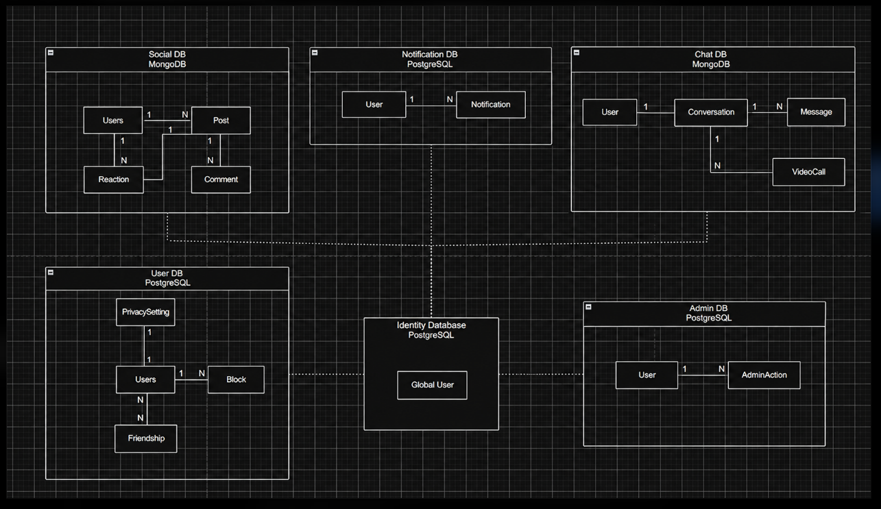

2.3. Database diagram
IdentityDB:
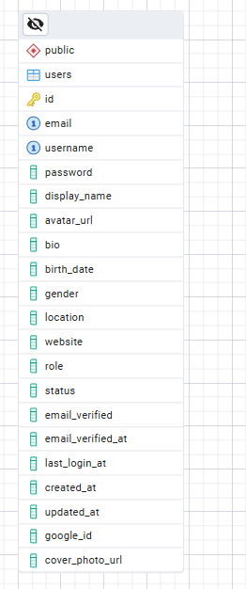

UserDB:
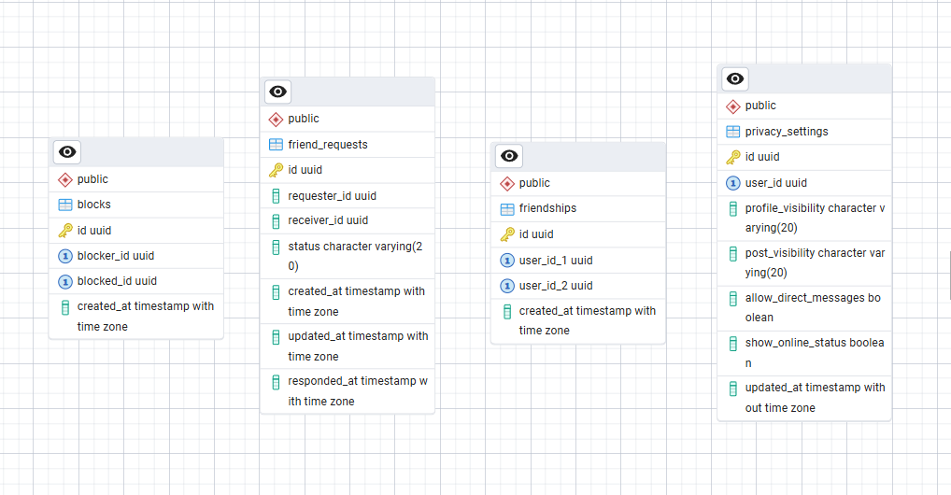

NotificationDB:
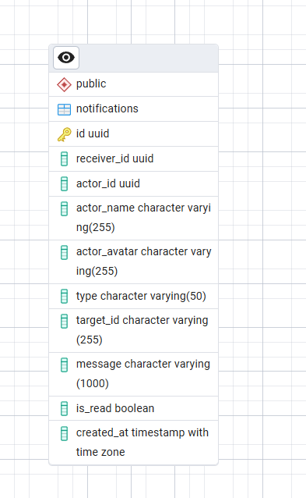

AdminDB:
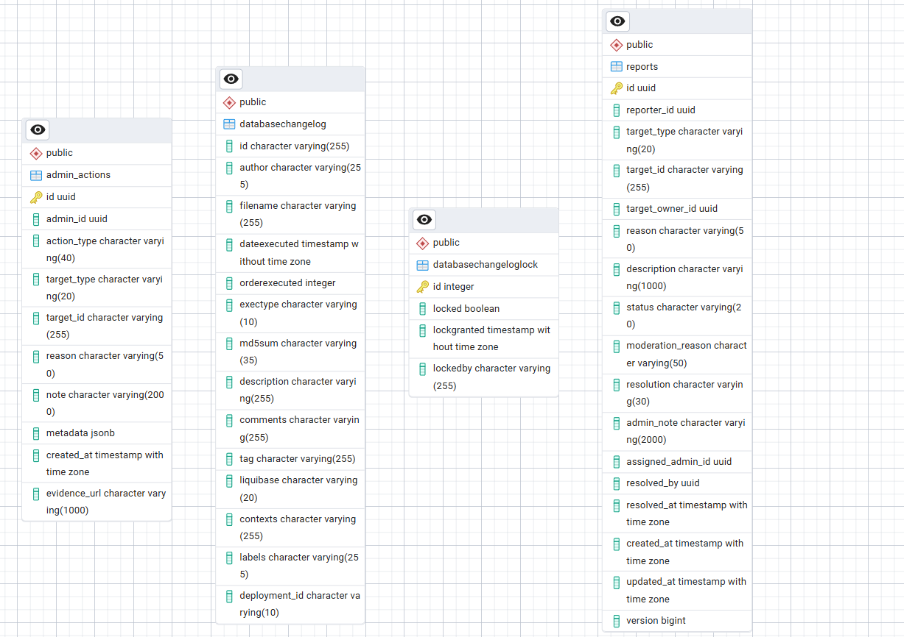
Identity records include suspended_until and moderation_reason to support time-limited account restrictions. Admin records include reports.version for optimistic concurrency control and admin_actions.evidence_url for optional moderation evidence.
SocialDB and ChatDB
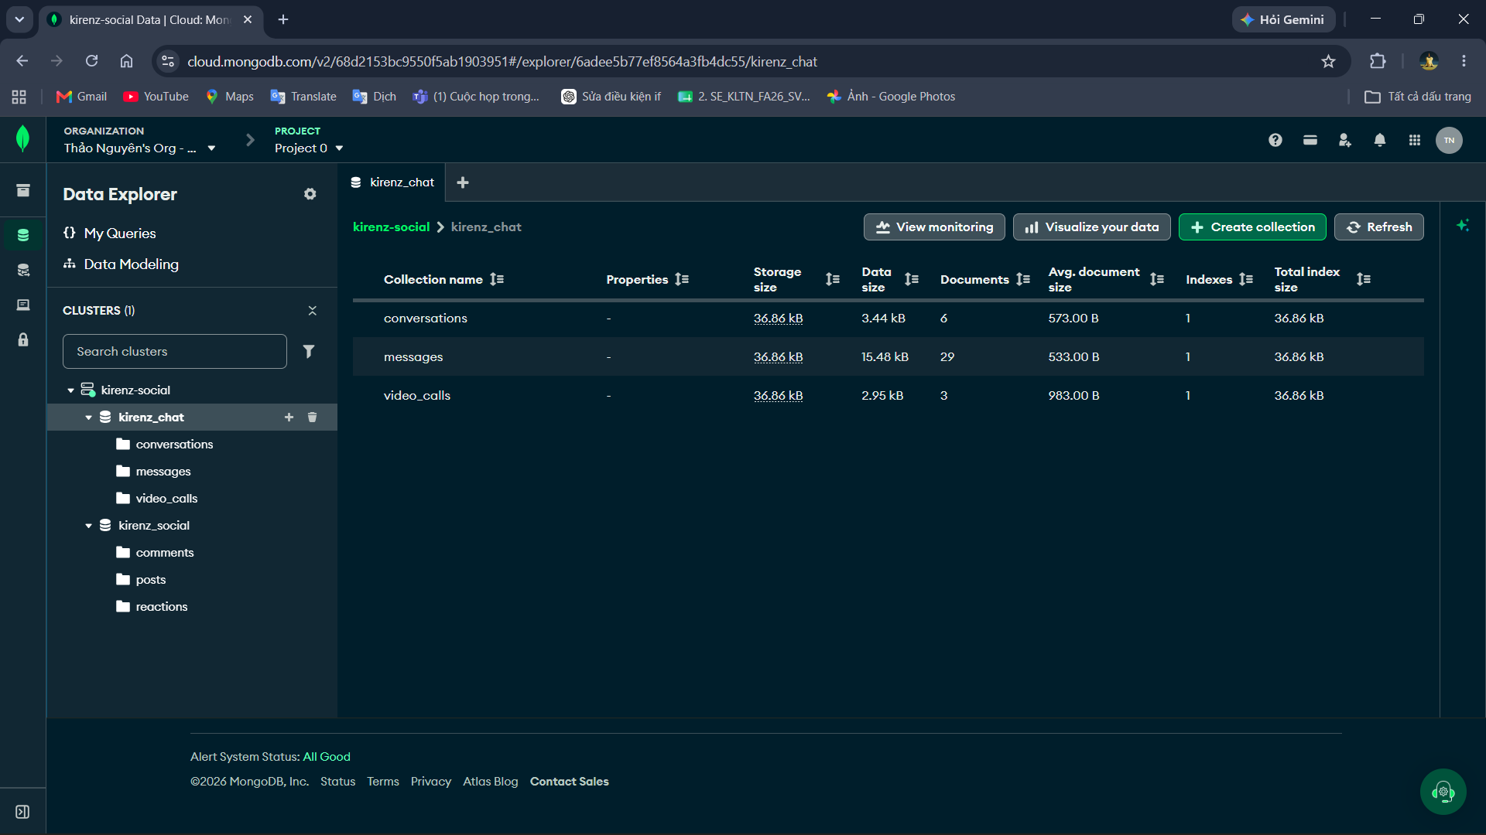
Social MongoDB stores posts, comments, and reactions. Posts contain author, visibility, media, tagged-user, sharing, and status data; comments support parentCommentId for replies; reactions identify one user and one target.
Chat MongoDB stores conversations, messages, and video_calls. Conversation documents embed participant IDs, administrator IDs, and nicknames. Video-call documents contain the conversation reference, caller/callee UUIDs, room and participant identities, status, completion reason, timestamps, heartbeat data, cleanup state, and revision.

2.4. Relationship Explanation
- `users.id` is the global identity reference used as `userId`, `requesterId`, `receiverId`, `senderId`, `actorId`, or `receiverId` in other services.
- A friend request connects one requester to one receiver. When accepted, the application creates one friendship record.
- A block connects a blocker to a blocked user. Each user has at most one privacy-setting record.
- A post belongs to one user and may contain many media objects and tagged-user UUIDs. A shared post points to `originalPostId`.
- A comment belongs to one post and one user. `parentCommentId` supports replies.
- A reaction belongs to one user and one target, where the target is either a post or comment.
- A conversation stores participant UUIDs, administrator UUIDs, and participant nicknames and may contain many messages. Each message belongs to one conversation and sender. Group membership is represented within the conversation document.
- A notification belongs to one receiver and optionally refers to an actor and a target object.
- A report belongs to one reporting user and identifies a post, comment, or account as its target. It records the review state, moderation outcome, and responsible administrator where applicable.
- An administrative action records the acting administrator, target, action type, reason, optional note/evidence, and creation time. Identity and content changes are applied through the owning services.
- A video-call session belongs to one direct conversation and identifies its caller and recipient. Call history summaries are stored as conversation messages.

System Architecture (Microservices Architecture)

3.1. Operating Environment
Kirenz is designed for users distributed across geographical locations and time zones. A user needs an internet connection and a current browser. Application HTTP requests and WebSocket signaling enter through the API Gateway, while browsers connect to LiveKit separately for call media. In development, the application services can run on one workstation. In production, the frontend, Gateway, services, and data infrastructure should run on controlled container hosts, while Cloudinary, LiveKit, and the transactional email provider are accessed as managed external services. Video calling requires browser camera and microphone permissions and a secure browser context, such as HTTPS or localhost during development.

3.2. Recommended Development Environment
Component | Minimum/Recommended Requirement
Developer workstation | 64-bit Windows, Linux, or macOS; 4 CPU cores; 8 GB RAM minimum, 16 GB recommended; at least 10 GB free storage.
Backend runtime | Java Development Kit 21 and Maven Wrapper.
Frontend runtime | Node.js 18 or later and npm
Containers | Docker Engine/Docker Desktop with Docker Compose
Databases | PostgreSQL for Identity, User, Notification, and Admin services; MongoDB for Social and Chat services.
Messaging/cache | Apache Kafka and Redis
Video calling | LiveKit connectivity and browser camera/microphone permissions; HTTPS for remote use or localhost during development.

In production, Linux-based container hosts, TLS termination, managed secrets, database backups, centralized logs, and restricted network access are recommended. Only the frontend and API Gateway should be public. Databases, Kafka, Redis, Eureka, and direct service ports should remain private. Services should be deployed near their databases to reduce latency. Time values are stored as instants and converted by the client for different user time zones.

3.3. High-level architecture
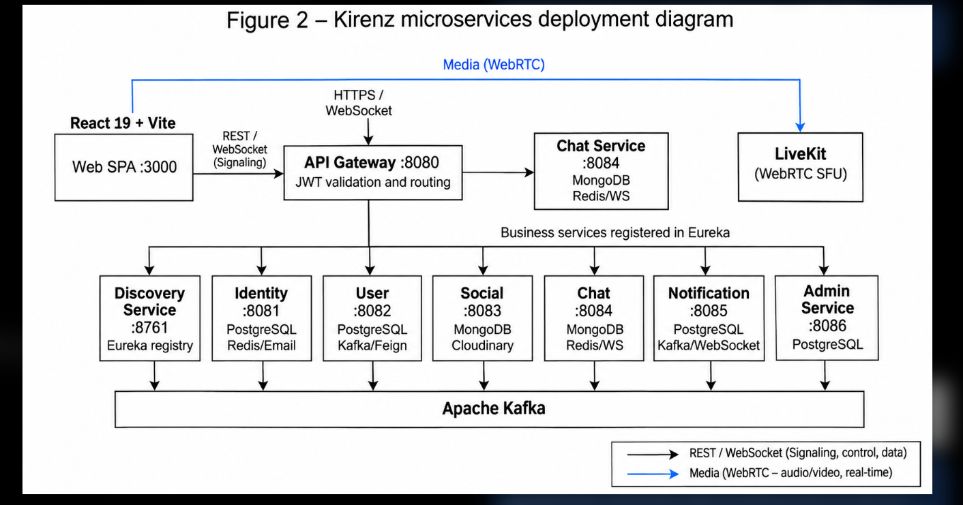
The React single-page application calls the API Gateway for application APIs. The Gateway routes authentication, verification, and profile paths to Identity Service; relationship, privacy, and user-search paths to User Service; social-content and media paths to Social Service; conversations, messages, presence, video-call operations, and chat WebSocket paths to Chat Service; notification HTTP/WebSocket paths to Notification Service; and administration, reports, and moderation paths to Admin Service. Admin Service runs on port 8086. Eureka resolves service instances. Browsers connect directly to LiveKit for audio and video after obtaining authorized room access from Chat Service.

3.4. Service Responsibilities
Component | Data Store | Main Responsibility
Frontend | Browser state | Responsive React/TypeScript interface, routing, forms, API integration, and WebSocket subscriptions
API Gateway | None | Single entry point, route matching, JWT validation, CORS/header handling, and load-balanced forwarding
Discovery Service | In-memory registry | Eureka service registration, discovery, and health visibility
Identity Service | PostgreSQL, Redis | Registration, password/Google login, OTP verification, JWT issuing/refresh, account status, and profile data
User Service | PostgreSQL | Friend requests, friendships, mutual friends, suggestions, blocks, and privacy settings
Social Service | MongoDB | Feed, posts, sharing, comments, replies, reactions, hashtags/model, and Cloudinary media upload
Chat Service | MongoDB, Redis | Direct/group conversations, messages, attachments, typing, presence, delivery/read status, video-call signaling and authorization, and persistent call history.
Notification Service | PostgreSQL | Kafka event consumption, notifications, unread count, read state, birthdays, and real-time delivery
Admin Service | PostgreSQL | Administrative analytics, user management, report review and resolution, content moderation, audit history, and service/infrastructure health monitoring.
Apache Kafka | Kafka log | Asynchronous event distribution and loose coupling
Redis | In-memory key/value | Temporary OTP/authentication data, online presence, and participant locks for call coordination.
Cloudinary | Object/CDN storage | Avatar, cover, post, and chat media storage/delivery
LiveKit | Managed media rooms | Real-time one-to-one audio/video transport using room-scoped participant access.

3.5. Communication Design
Normal operations use JSON over HTTP/REST. Media upload uses `multipart/form-data`. Chat and notifications use STOMP over WebSocket/SockJS so the server can push updates without polling. The client includes the access token with protected requests and WebSocket connection metadata.

OpenFeign is used when a service requires an immediate response. User Service retrieves identity profiles, Social Service resolves author and friendship data, Chat Service checks direct-message privacy and participant profiles, and Notification Service resolves actor information. Admin Service uses internal HTTP clients to query analytics and apply account or content moderation through the owning services. Eureka-based service names provide runtime location, and Resilience4j circuit-breaker and retry configuration limits cascading failure.

Apache Kafka handles cross-service side effects, including user-created events, friend and social notification events, and report or moderation notifications. Notification Service consumes relevant events, persists notifications, and pushes them to connected recipients. Direct chat delivery follows a separate path: Chat Service validates a message, saves it to MongoDB, updates the conversation, and broadcasts the result through WebSocket. Typing updates are also broadcast through WebSocket, while Redis supports online presence.
Chat Service owns video-call signaling, participant authorization, and persistent call state. Authenticated REST endpoints create, accept, decline, and end calls, while the private WebSocket call queue delivers state changes to both participants. After acceptance, the backend issues short-lived tokens scoped to the LiveKit room. Browsers connect to LiveKit for audio and video delivery. MongoDB stores call sessions, and Redis coordinates participant locks. Ending a call updates both clients, closes the media room, and adds a summary to conversation history.
Notification Sequence:

Send-message sequence:
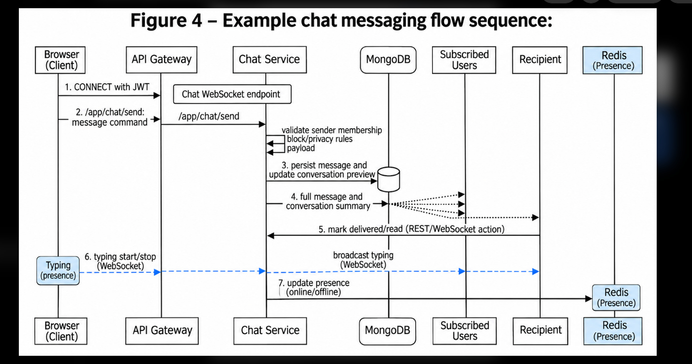

3.6. Technology Learned and Applied
1. Spring Cloud Gateway: centralizes routes and token validation.
2. Netflix Eureka: dynamically resolves service instances.
3. Apache Kafka: implements event-driven workflows and loose coupling.
4. WebSocket, STOMP, and SockJS: provide real-time chat, notifications, typing, presence updates, and private call-state signaling.
5. OpenFeign and Resilience4j: combine declarative HTTP clients with circuit breaking and retry.
6. Polyglot persistence: applies PostgreSQL, MongoDB, and Redis to different access patterns.
7. Liquibase: versions relational schema changes.
8. Cloudinary: separates media storage/delivery from application containers.
9. React, TypeScript, Zustand, TanStack Query, and Axios: provide a typed, responsive SPA.
10. Docker Compose: describes a repeatable multi-container environment.
11. LiveKit and WebRTC: provide room-based one-to-one audio/video communication with backend-issued participant access.

Implementation

Deployment Considerations
Required Configuration:
The operator must provide:

- `JWT_SECRET` shared by token-issuing and token-validating components.
- Separate PostgreSQL URLs and credentials for Identity, User, Notification, and Admin services. Admin configuration includes ADMIN_DATABASE_URL, ADMIN_DATABASE_USERNAME, and ADMIN_DATABASE_PASSWORD.
- Separate MongoDB URIs/databases for Social and Chat services.
- Kafka bootstrap servers and Redis host, port, and password.
- Eureka default-zone URL when discovery is enabled.
- Google OAuth client ID.
- Brevo API key and sender identity for OTP mail.
- Cloudinary cloud name, API key, API secret, folders, and upload-size limits.
- Frontend API and WebSocket base URLs.
- LIVEKIT_URL, LIVEKIT_API_KEY, and LIVEKIT_API_SECRET for Chat Service to access the media provider.
- LIVEKIT_TOKEN_TTL, LIVEKIT_RING_TIMEOUT, and LIVEKIT_DISCONNECT_TIMEOUT for join-token validity and call timeouts. Defaults are two minutes, 60 seconds, and 45 seconds respectively. Join-token validity does not limit the duration of an established call.

Secrets must not appear in screenshots, committed `.env` files, source code, or this report. Local defaults are for development only and must be replaced before public deployment.

Infrastructure and Capacity:
The repository's Docker Compose file builds the frontend and eight Spring components: Identity, User, Social, Chat, Notification, Admin, API Gateway, and Discovery. It also starts Kafka and Redis. PostgreSQL and MongoDB containers are not defined in the current Compose file; database URLs and URIs are supplied through environment variables. The team must provision reachable database instances or add database containers, persistent volumes, initialization, and health checks before starting the complete stack.

PostgreSQL requires four logical databases owned by Identity, User, Notification, and Admin services. MongoDB uses isolated databases for Social and Chat services. Persistent volumes and scheduled backups are required in production. Kafka and Redis require appropriate persistence, authentication, and private network access. LiveKit is configured as an external media service.

Database Migration:
Liquibase change logs exist for the four PostgreSQL-owned schemas. Migration execution is disabled by default and controlled by IDENTITY_LIQUIBASE_ENABLED, USER_LIQUIBASE_ENABLED, NOTIFICATION_LIQUIBASE_ENABLED, and ADMIN_LIQUIBASE_ENABLED. Deployment must apply the migrations before starting services with Hibernate validation or deliberately enable Liquibase after checking permissions and ordering. Schema backup and rollback procedures should be tested before a production upgrade.

Installation and Start-up Procedure:
1. Install JDK 21, Node.js 18+, npm, Docker, PostgreSQL, and MongoDB or obtain managed database endpoints.
2. Create the Identity, User, Notification, and Admin PostgreSQL databases and the Social and Chat MongoDB databases.
3. Supply the required database, JWT, Redis, Kafka, Google, Brevo, Cloudinary, and LiveKit environment values.
4. Apply the Liquibase change logs for Identity, User, Notification, and Admin databases.
5. Start Redis and Kafka with Docker Compose or equivalent managed infrastructure.
6. Start Discovery Service on port 8761.
7. Start Identity, User, Social, Chat, Notification, and Admin services on ports 8081–8086 and verify Eureka registration.
8. Start API Gateway on port 8080 and verify `/actuator/health`.
9. In `frontend`, run `npm install` and `npm run dev`, or build the Docker image. Open `http://localhost:3000`.
10. Smoke-test registration, OTP, login, profile updates, posts, friendship, chat, notifications, reports, administrative moderation, and one-to-one video calls.

For a containerized demonstration, provide environment values in a private .env file, provision the required databases, and run docker compose up --build. Verify external LiveKit connectivity and browser camera/microphone permissions before demonstrating video calls.

Testing and Quality Assurance:
The source inventory contains 45 Java test classes across the services and seven frontend test files. Backend coverage includes authentication, profiles and relationships, social content, notifications, conversations, administrative user management, report workflows, monitoring, and video-call authorization and signaling. Frontend tests cover route guards, the user hover card, and call service, provider, and room behavior. Request validation, database constraints, ownership checks, and centralized exception handlers provide additional runtime safeguards. Test inventory and execution results are recorded separately.

For the original report dated 18 July 2026, the frontend was recorded as passing TypeScript checking with npm run lint and completing a production Vite build with npm run build. That build reported optimization warnings for a large JavaScript chunk and mixed static/dynamic imports. The verification pipeline below covers the current submission.

The recommended final verification pipeline is:

1. Run all backend unit/integration tests with Maven.
2. Run TypeScript checking using `npm run lint`.
3. Run frontend unit tests using npm test.
4. Produce the frontend bundle using npm run build.
5. Start the stack and verify Eureka registration and Actuator health.
6. Test Gateway routes with valid, missing, expired, and malformed JWTs.
7. Use two browsers/accounts to test friend requests, notifications, direct/group chat, typing, presence, and read status.
8. Verify ownership, privacy, and block rules with different accounts.
9. Test invalid input, duplicate actions, dependency failure, reconnection, upload limits, and responsive layouts.
10. With two accounts, test incoming/outgoing video calls, acceptance, decline, cancellation, missed calls, hang-up, microphone/camera controls, device-permission errors, and reconnection. Verify that group conversations and unrelated users cannot obtain call access.
11. Test report submission, duplicate-report rejection, administrator review/dismissal/resolution, account restrictions, evidence notices, audit records, and authorization failures.

Screenshots and explanations
Public page for visitors
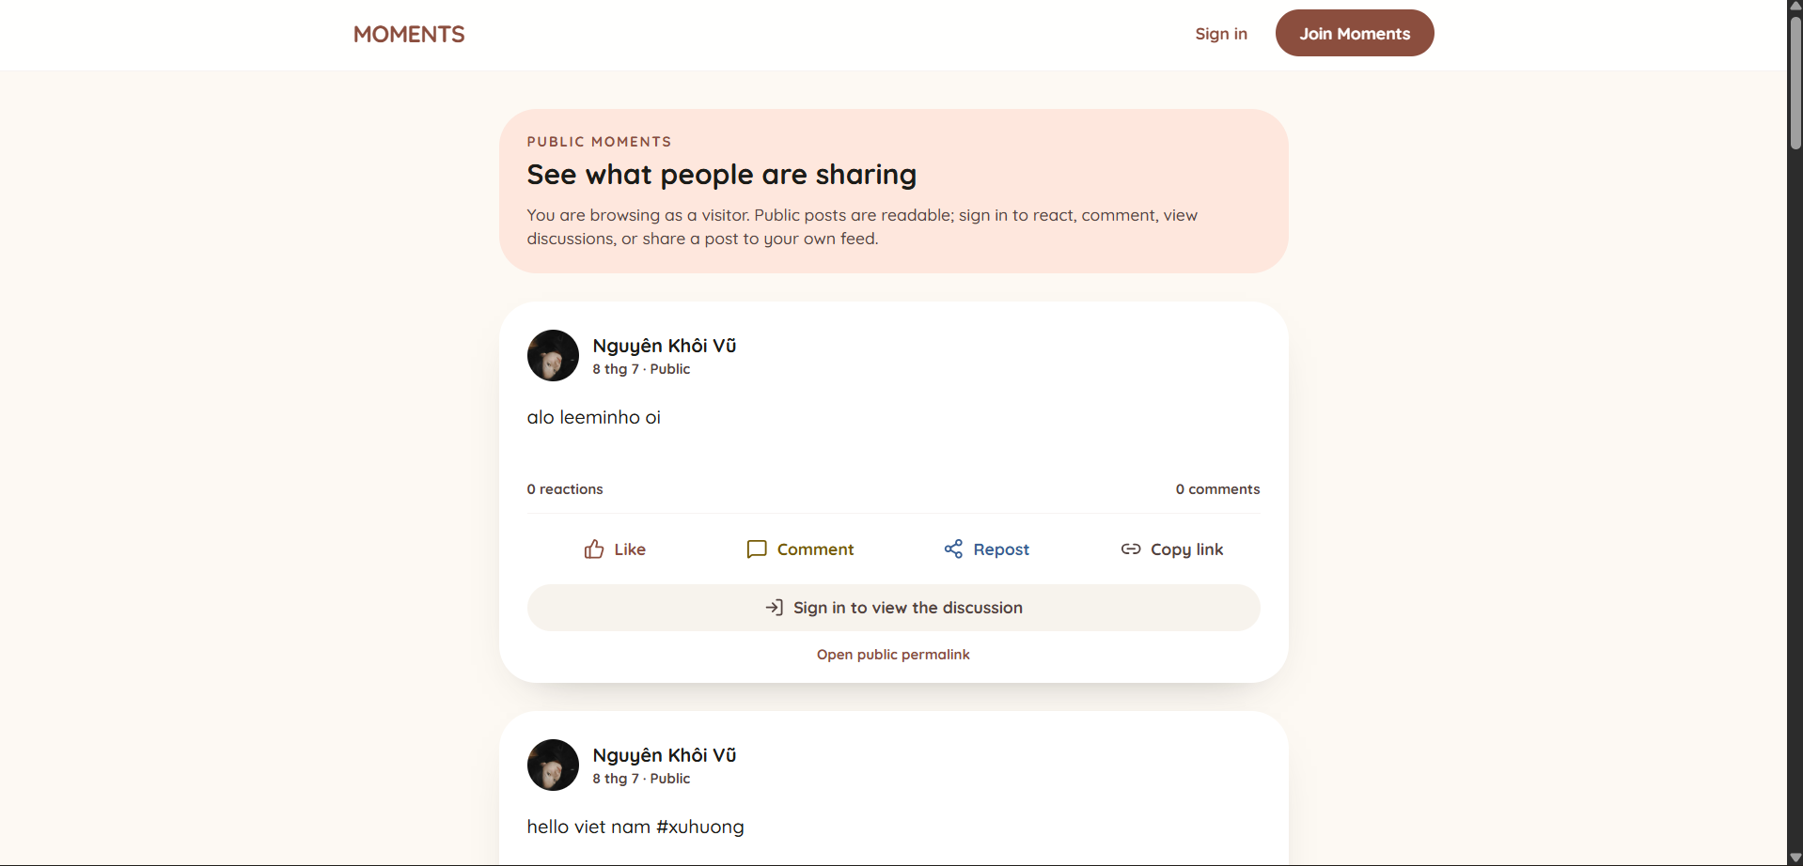

The root route allows an unauthenticated visitor to read active public posts. A stable `/posts/{postId}` permalink can be copied from a public post and opened without a session. Like, Comment, Repost, View discussion, and profile actions redirect to login while preserving the original URL. The public backend endpoints reject friend-only and private content as not found.

Login Screen

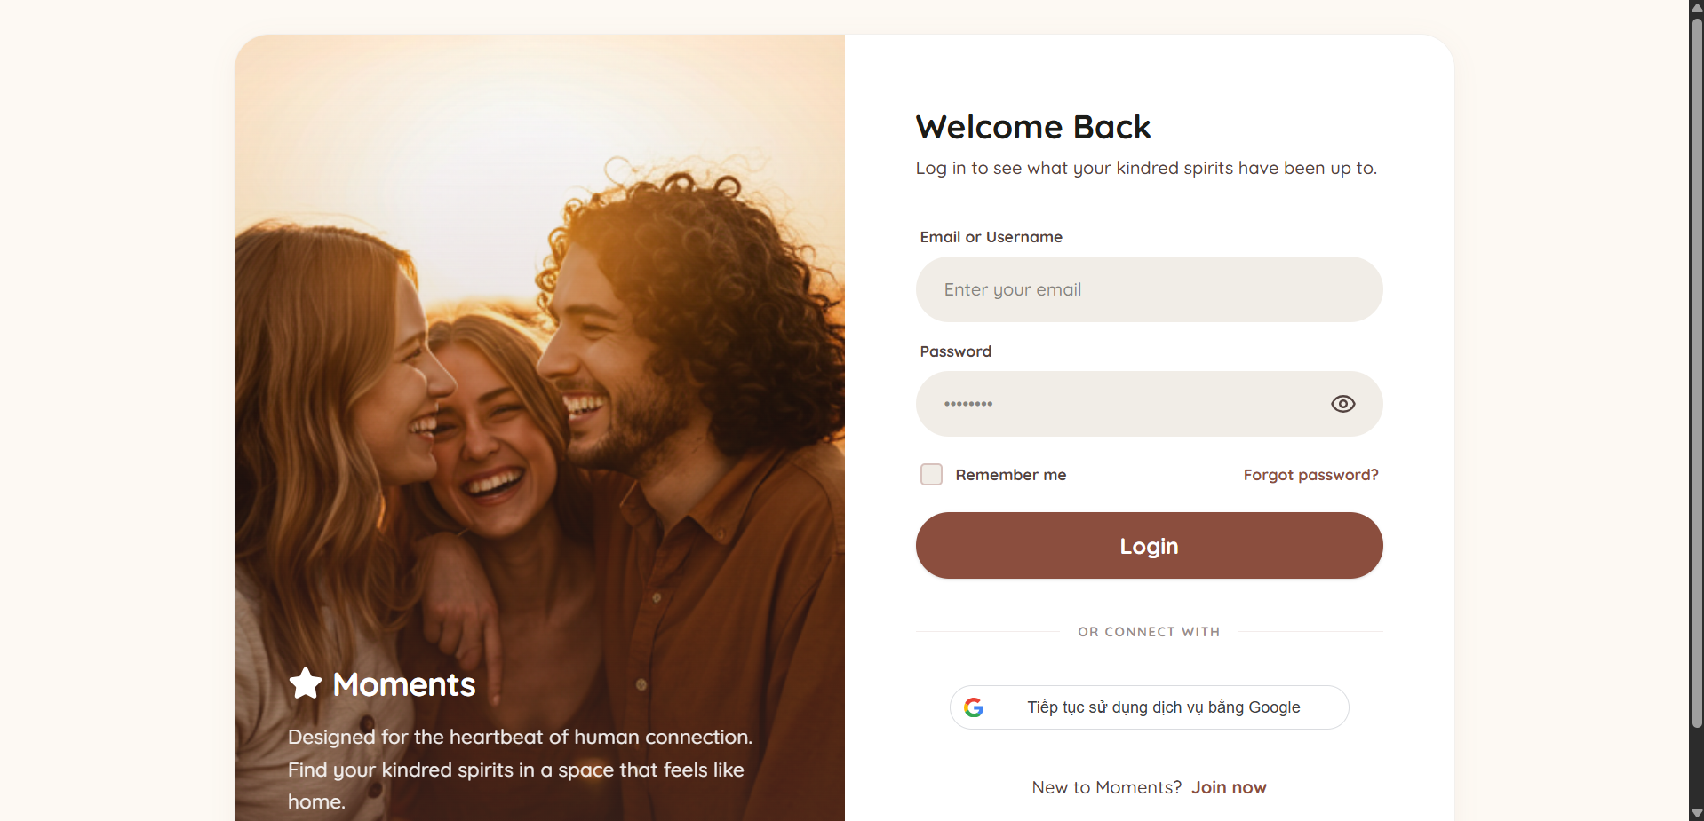

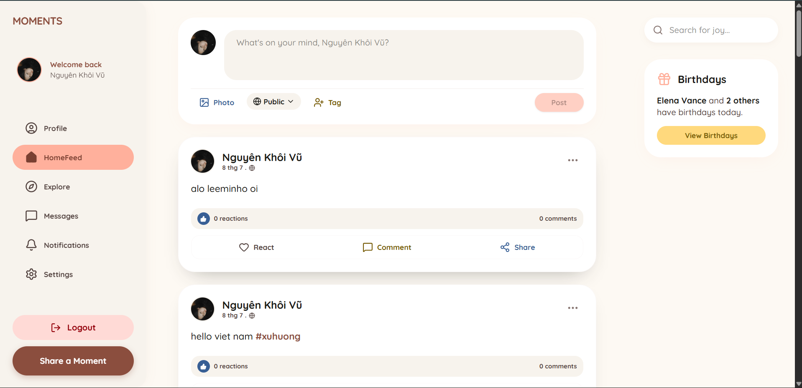

The login page at `/login` accepts email/password and offers Google authentication. On success, the client receives authenticated state and token data, then opens the protected Home Feed or returns to the safe internal URL supplied by the visitor flow. Validation and server errors are displayed without exposing sensitive internals.

Registration

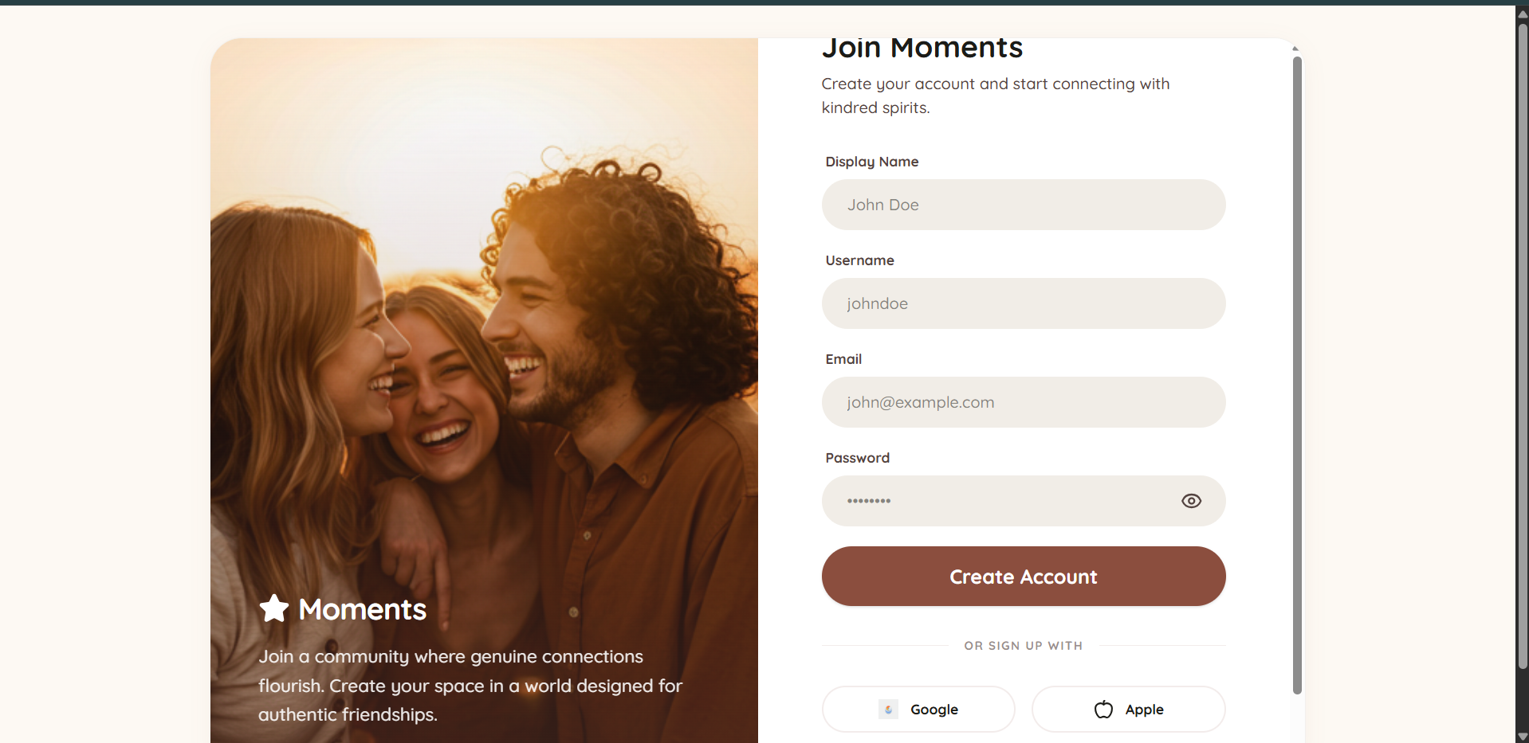
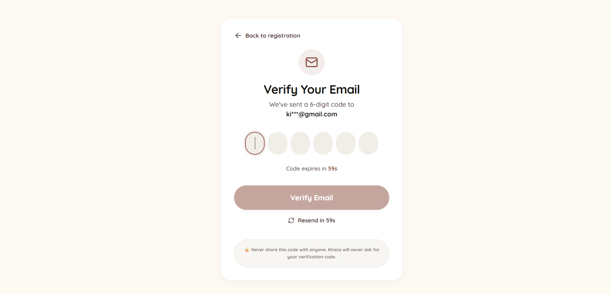
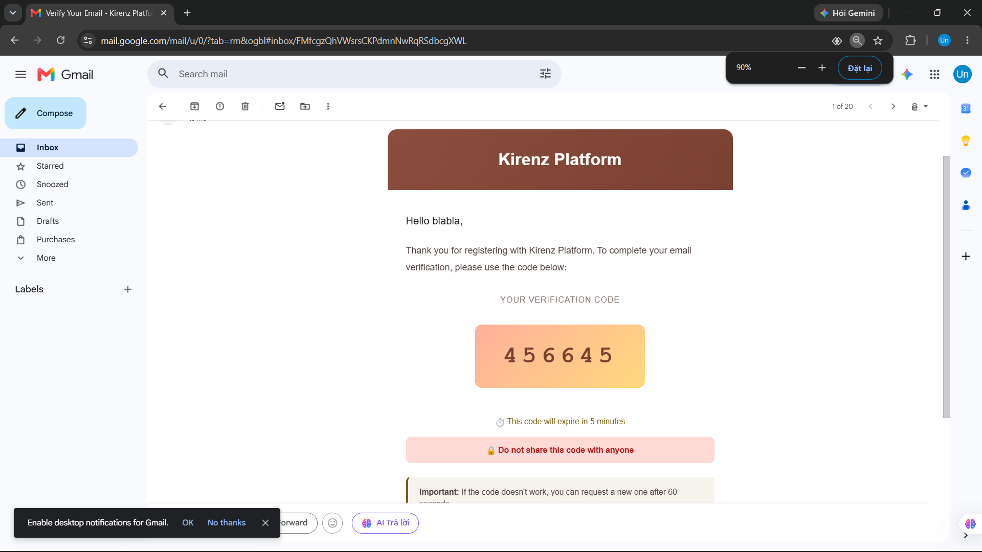
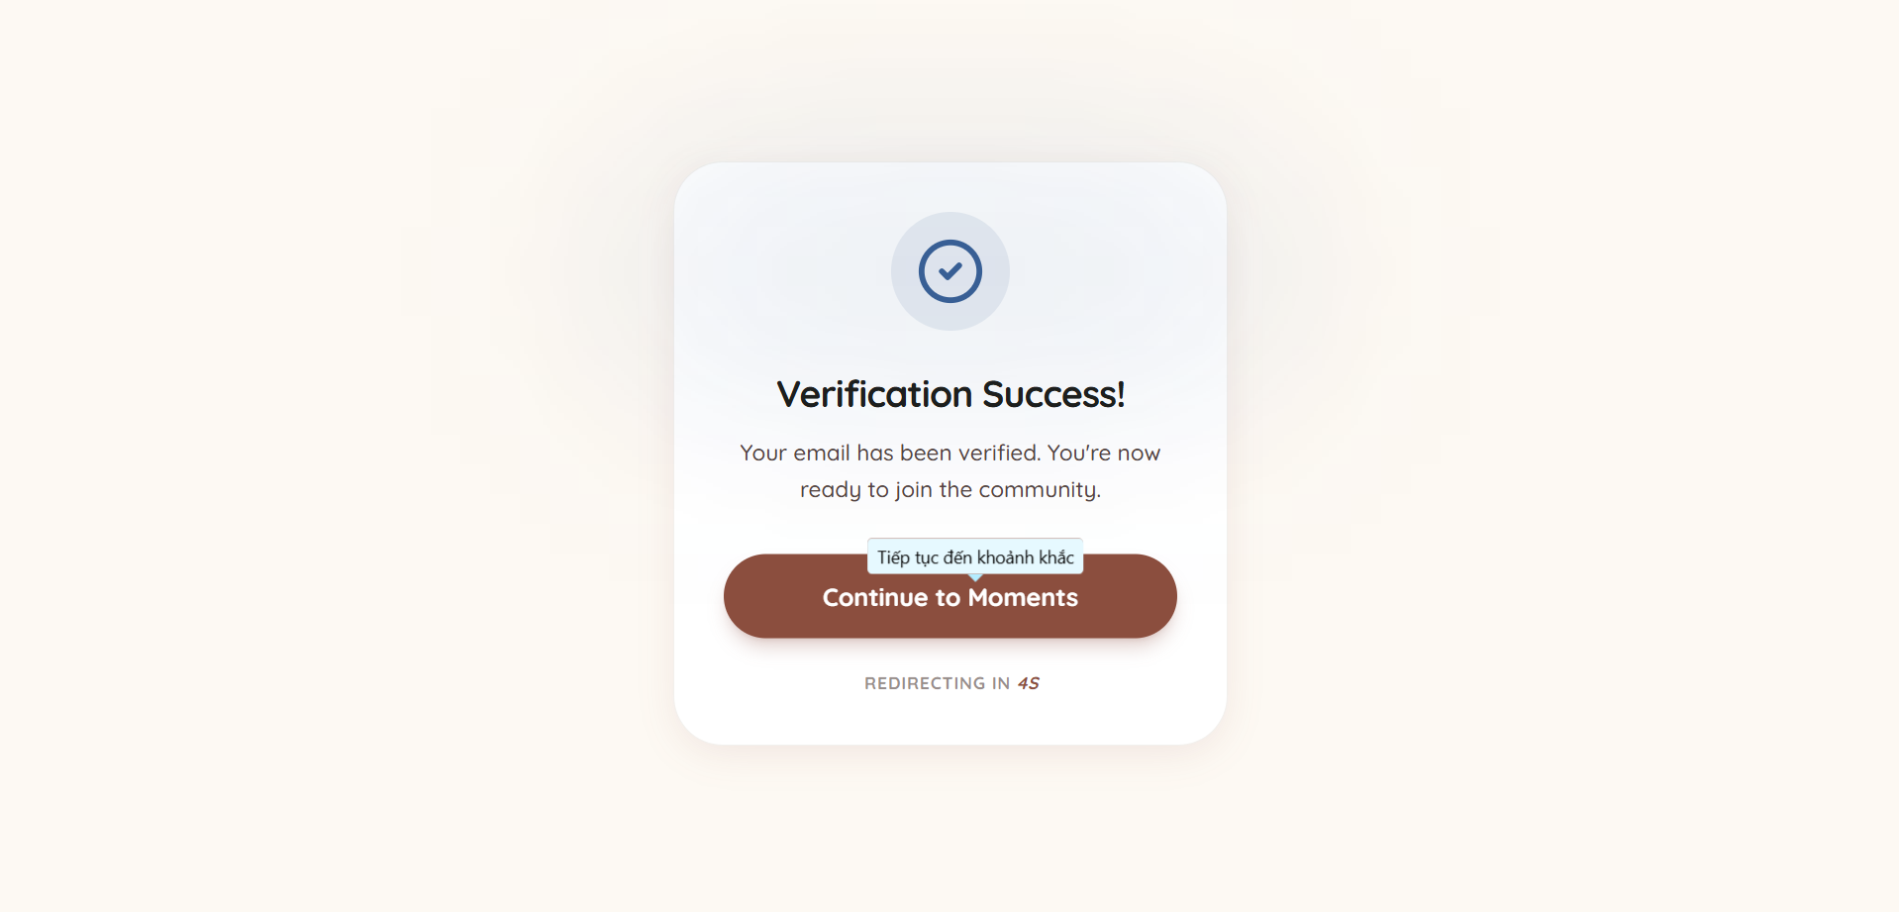

Registration collects display name, username, email, and password. The user then verifies the email with an expiring OTP. This demonstrates validation, unique identity constraints, Redis-backed temporary data, and transactional email integration.

Home Feed and Create Post
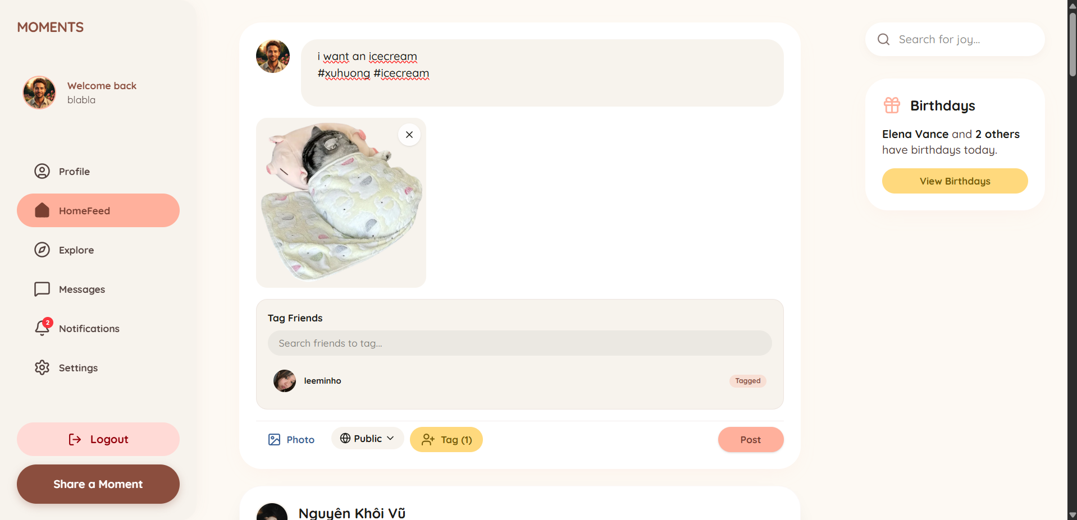

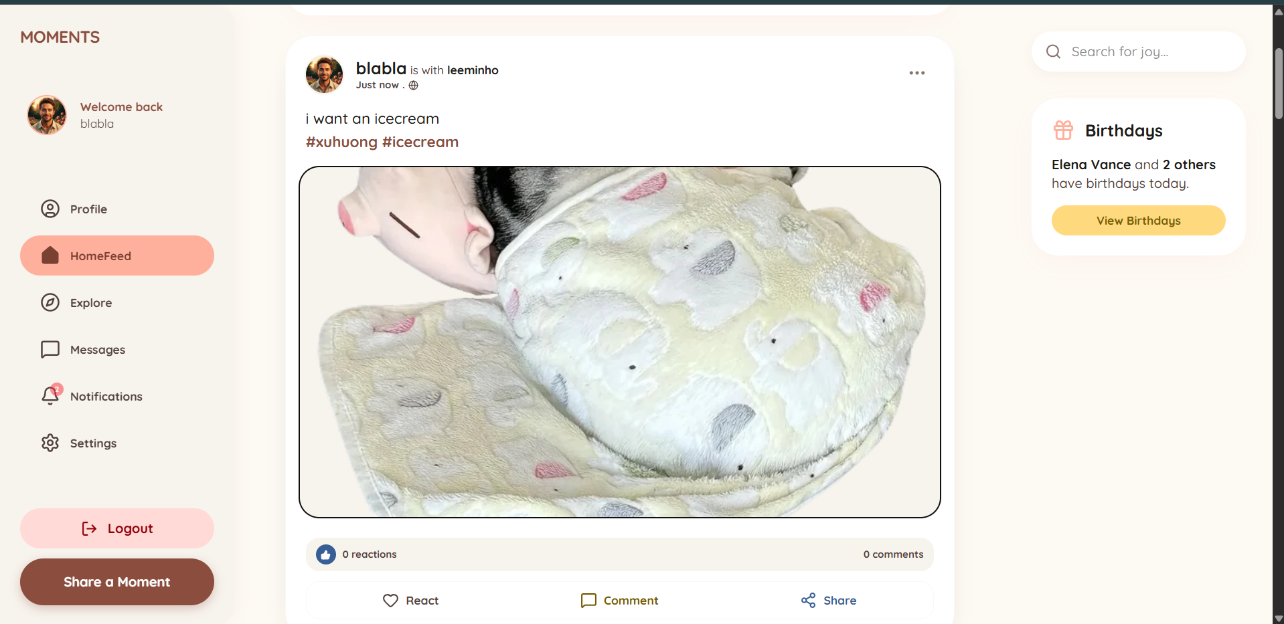

Home Feed is the primary social workspace. The composer supports text, uploaded images, tagged users, and visibility settings. A post card shows the author, time, media, counts, and interaction actions. Social Service applies visibility rules and returns feed pages through cursor pagination, allowing the interface to load more posts as the user scrolls.

Post Reactions and Comments

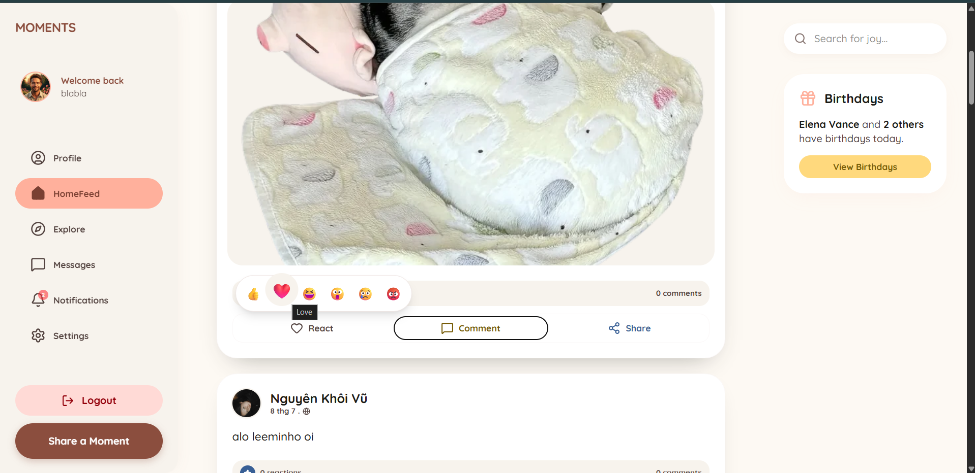

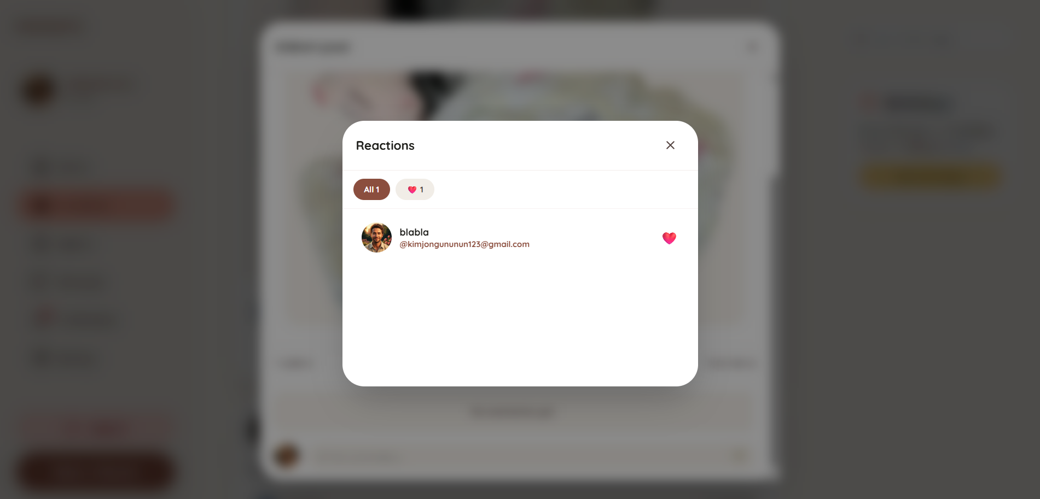

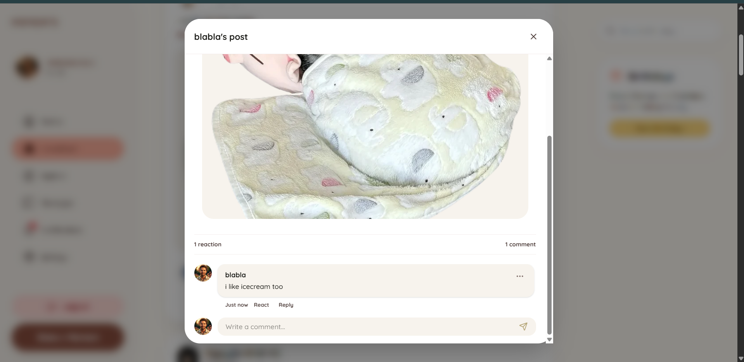

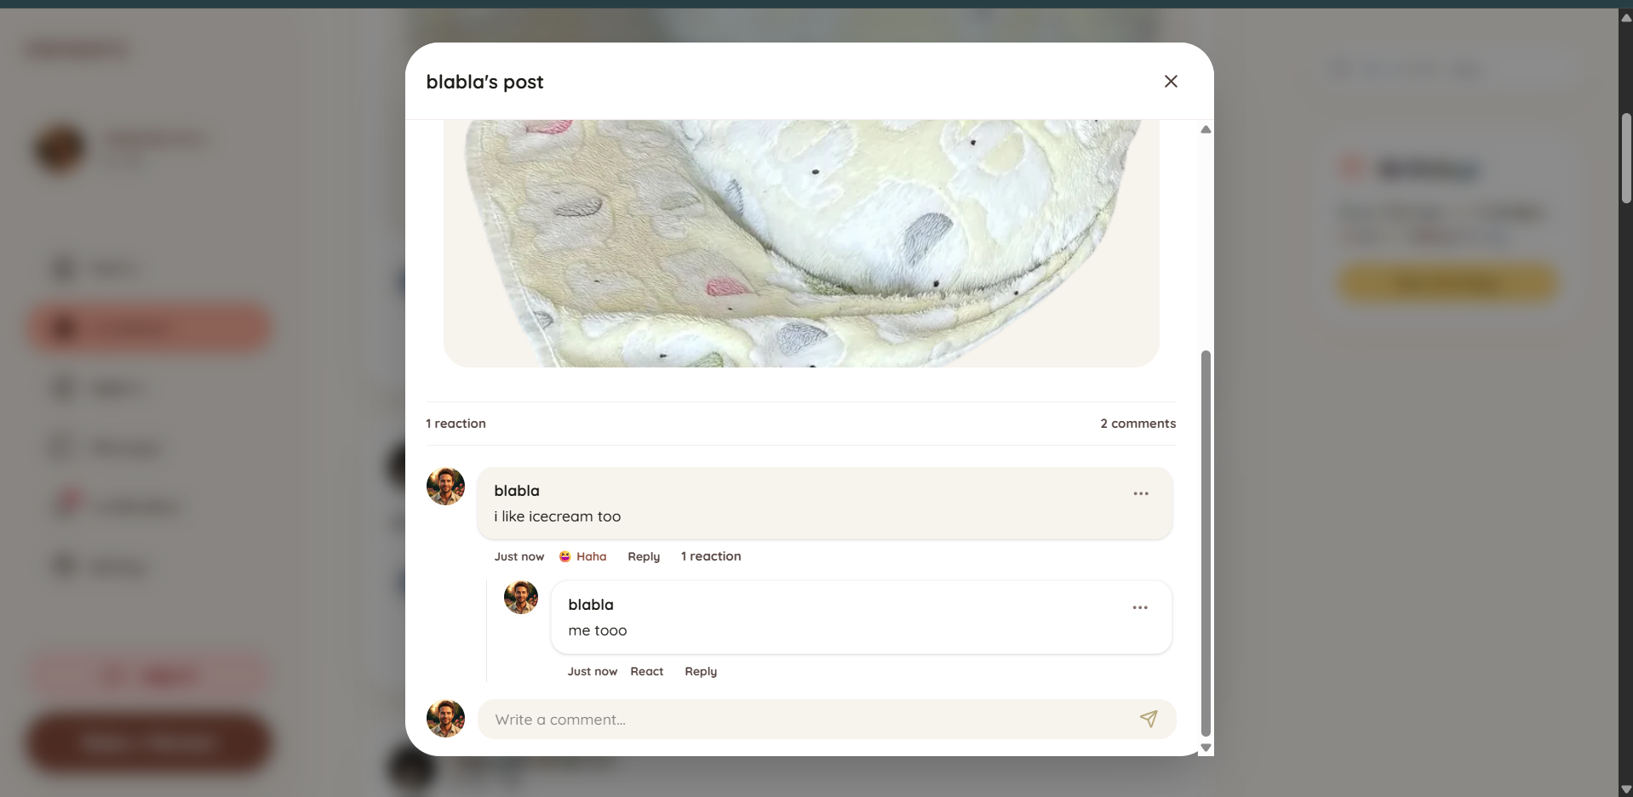

Users can select, change, or remove an emoji reaction, inspect summaries, and create threaded comments. A unique reaction constraint prevents duplicate reactions for one user/target. Comment and reaction events can create an asynchronous notification.
Report a Post or User
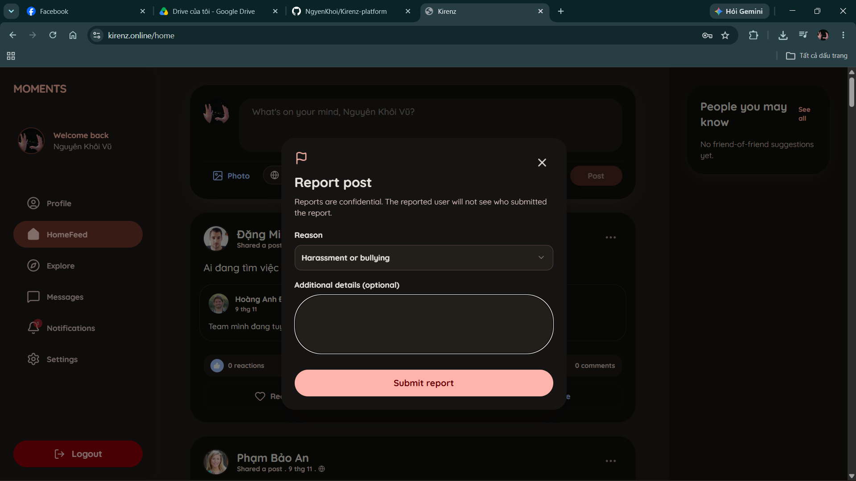
Registered users can report a post or profile from its action menu. The report dialog provides a reason selector and an optional description of up to 1,000 characters. After submission, the interface confirms that the report has been received. Admin Service stores the report for review and rejects duplicate reports from the same user while an earlier report for the target remains open.

Explore and Search
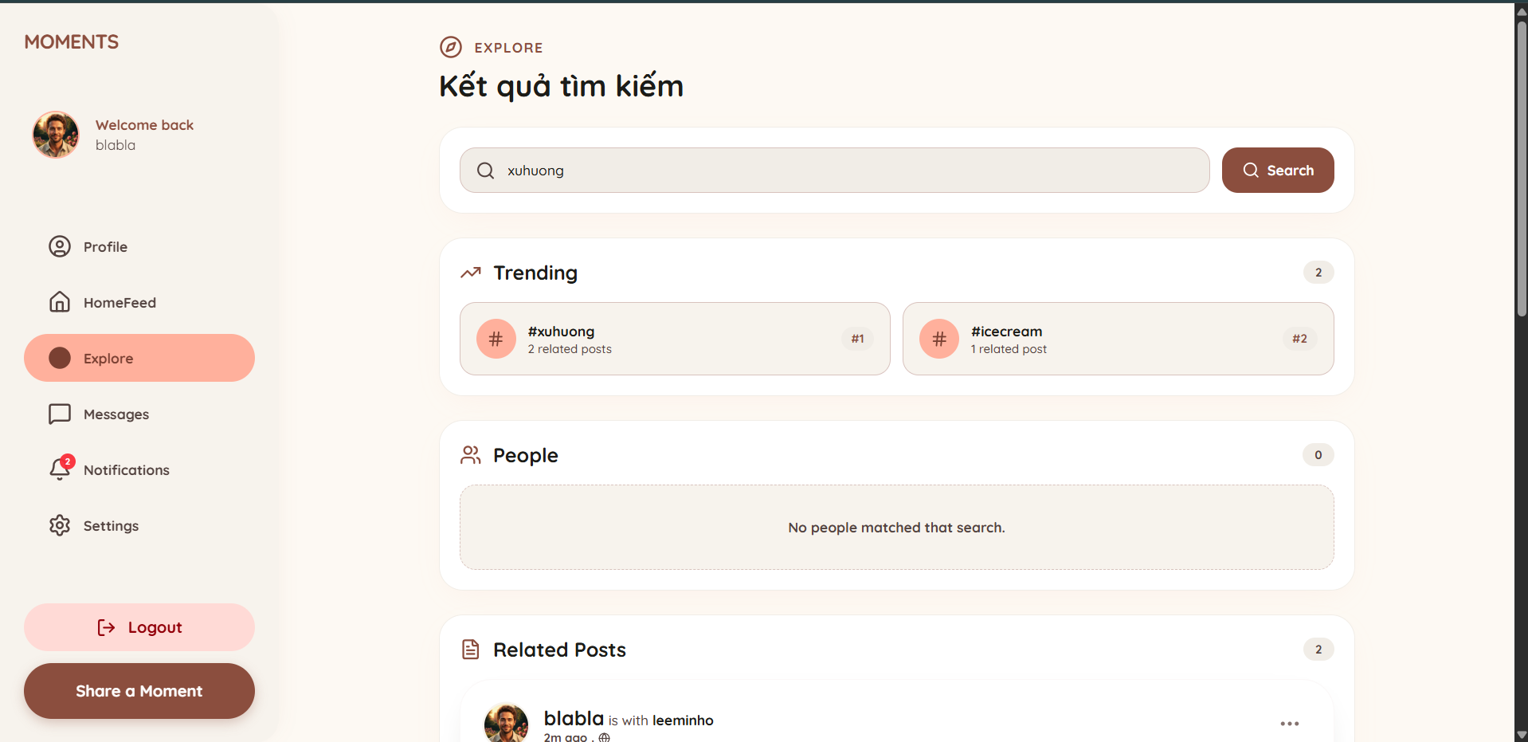

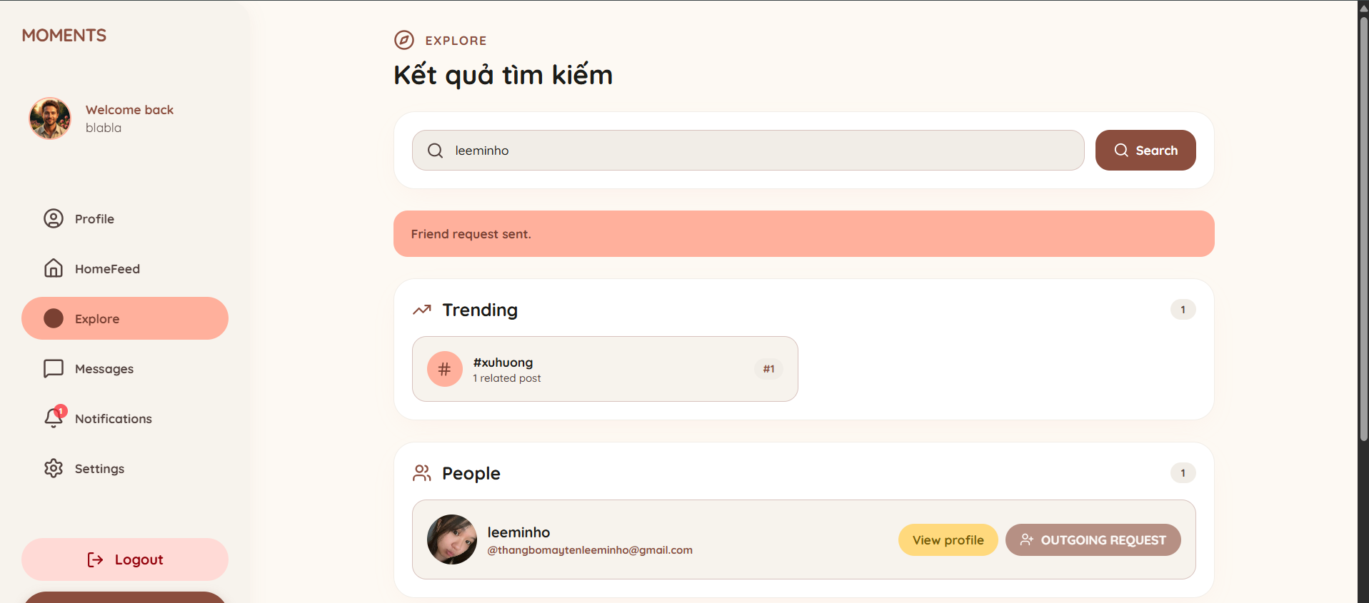

Explore searches people through User and Identity services and retrieves matching posts and hashtags through Social Service APIs. Results are loaded progressively using cursor pagination. Trending hashtags are calculated by the backend from visible posts within the latest 500-post window. Users can open a profile, send a friend request, or view a matching post.

User Profile and Friend Management

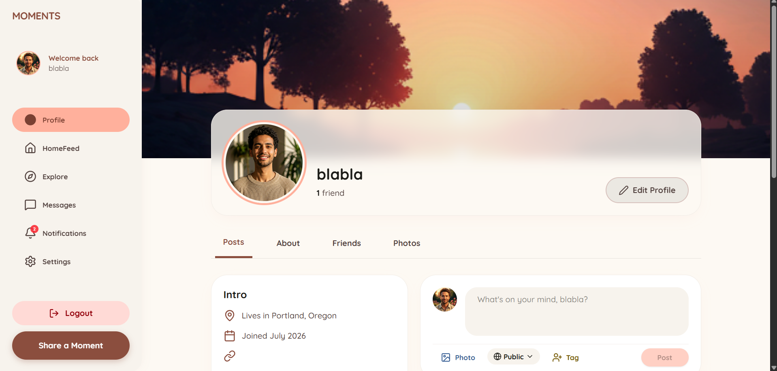

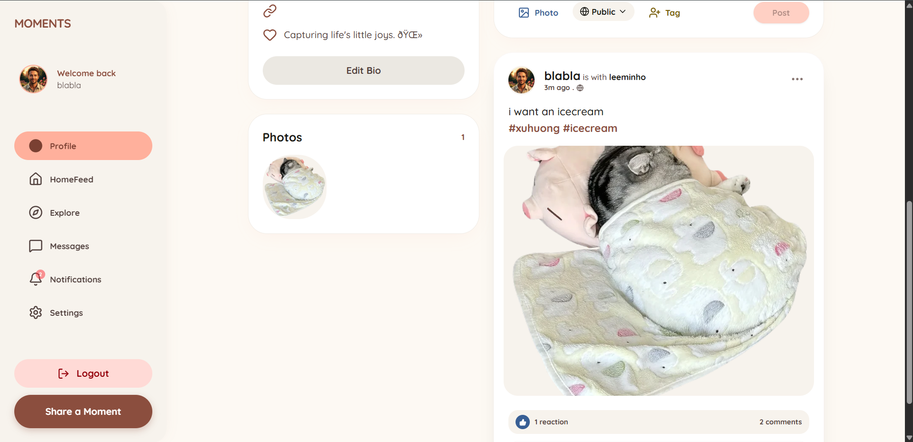
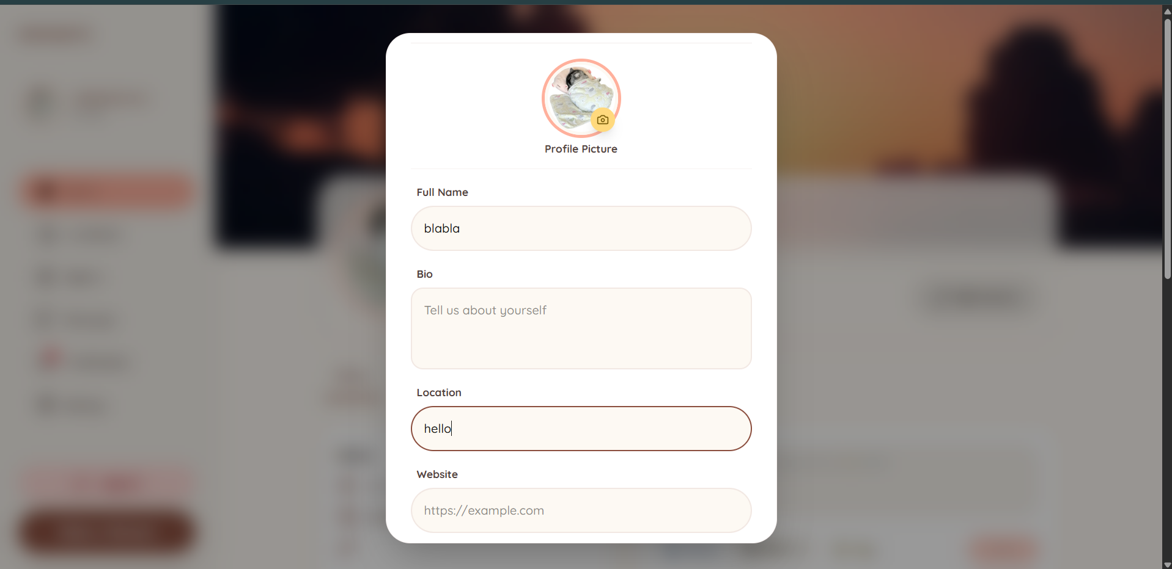
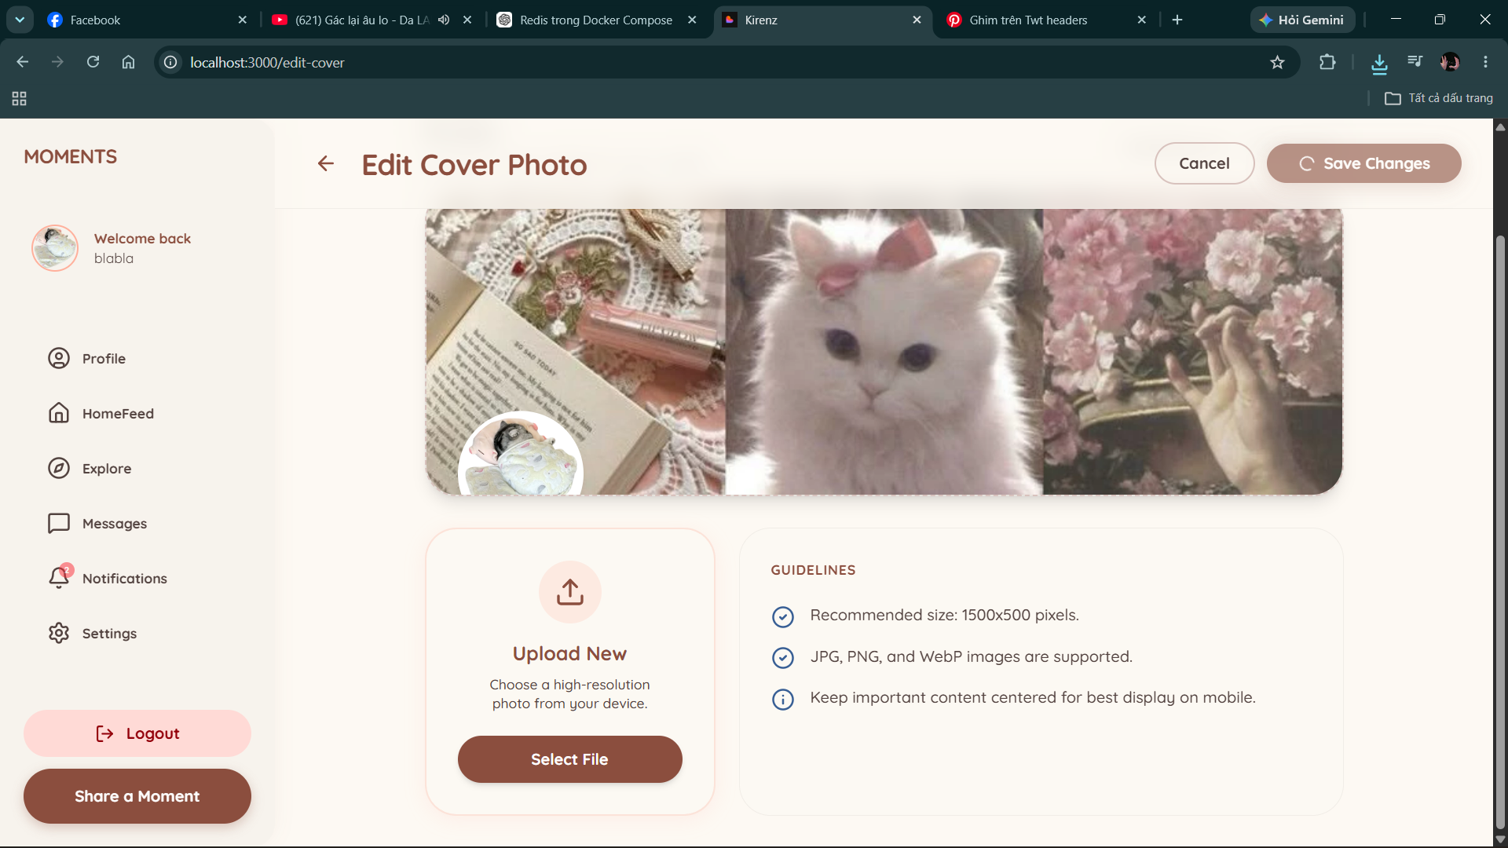
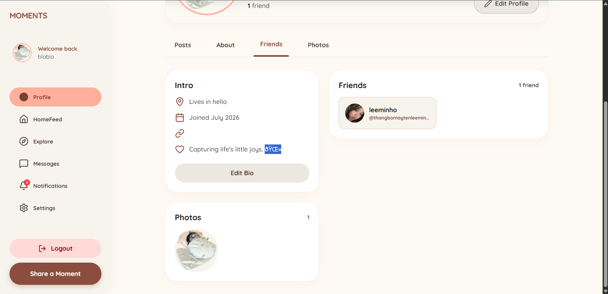
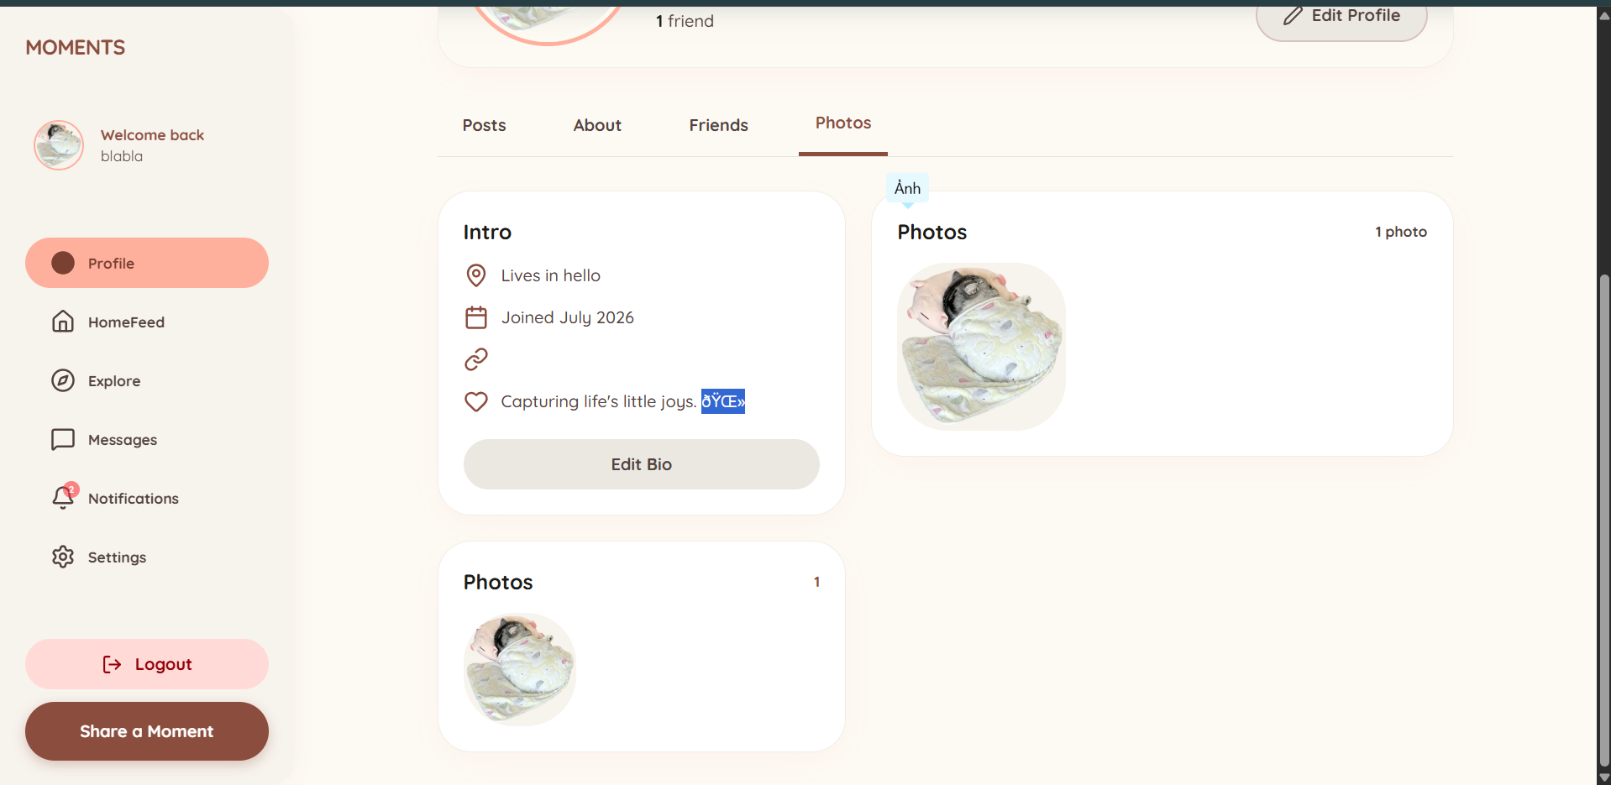

The profile combines identity fields, social posts/images, and relationship context from independent services. Depending on status, the viewer may send/cancel/accept a request, unfriend, block, or start a conversation. A hidden profile returns a controlled privacy view.

Profile Editing and Privacy Settings

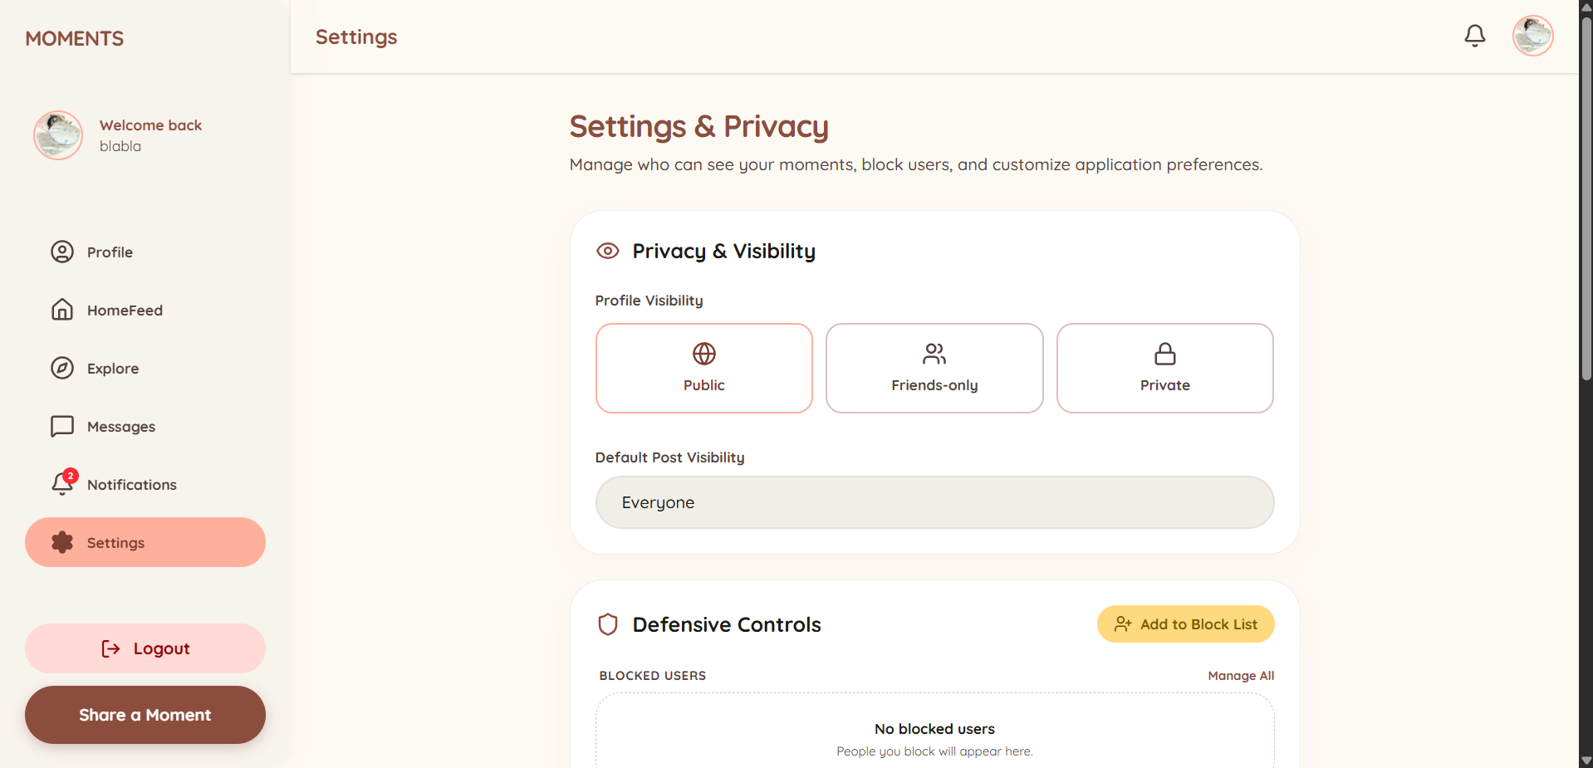

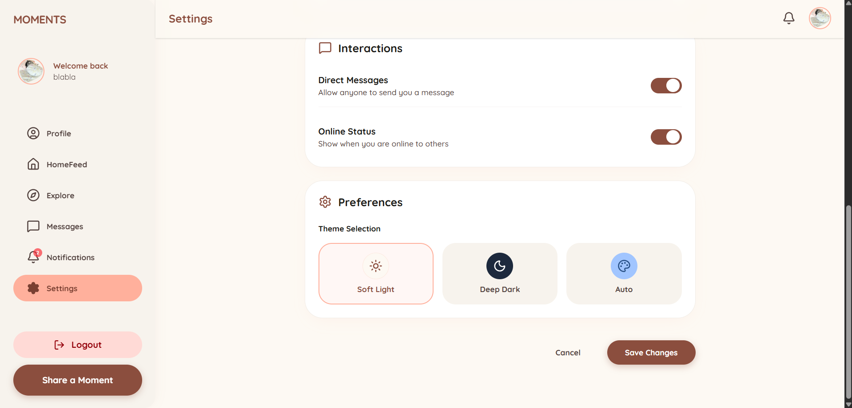

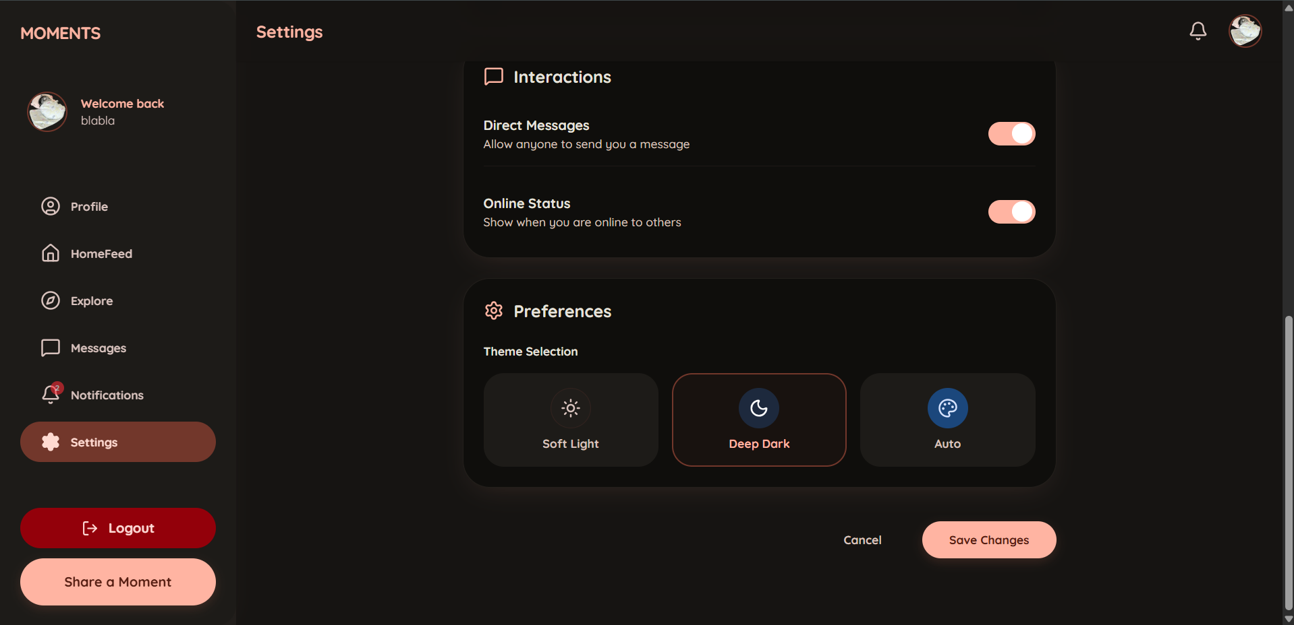

Privacy controls determine profile/post visibility, direct-message permission, and online-status visibility. Cloudinary hosts uploaded media; Identity Service stores its URL.

Direct Chat

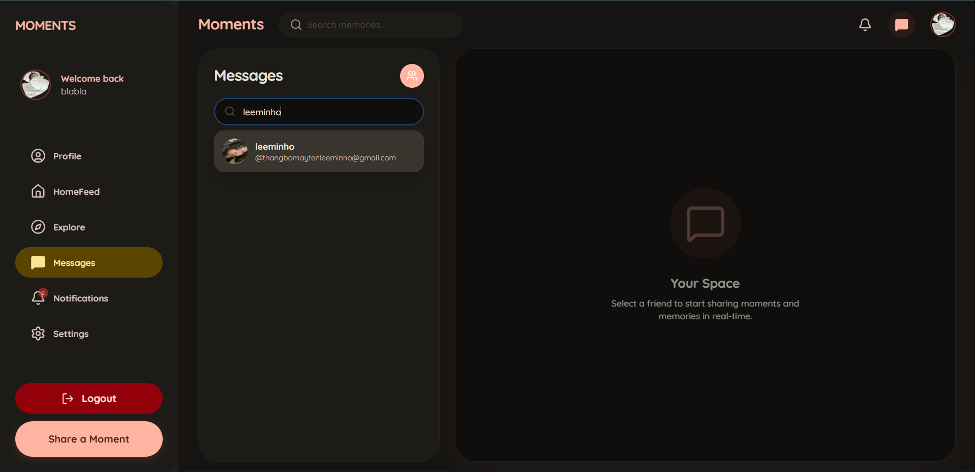
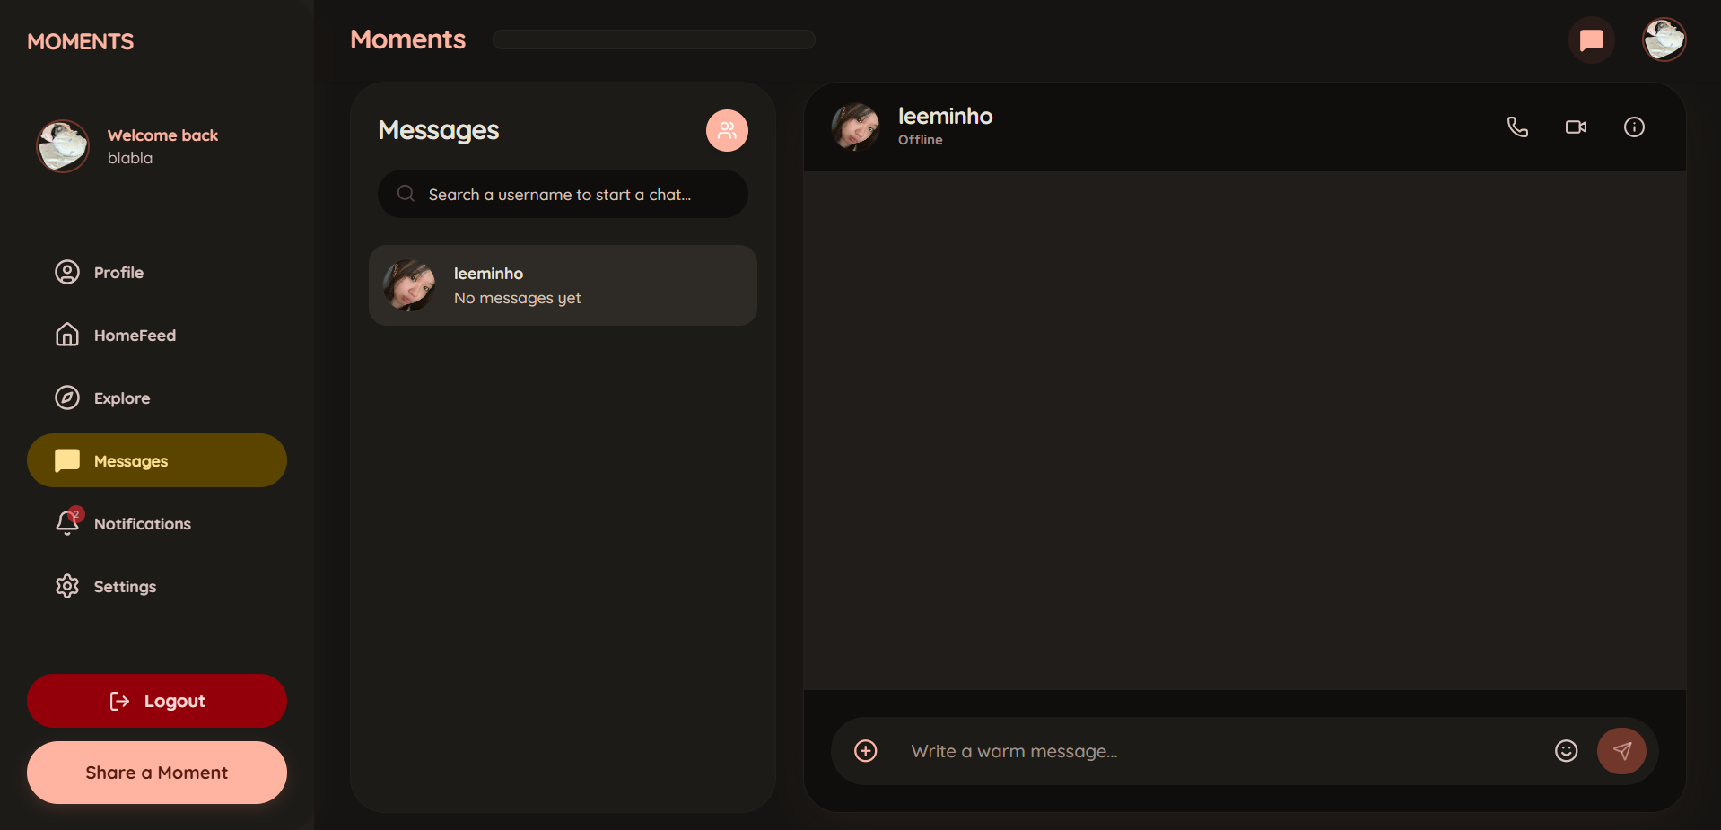
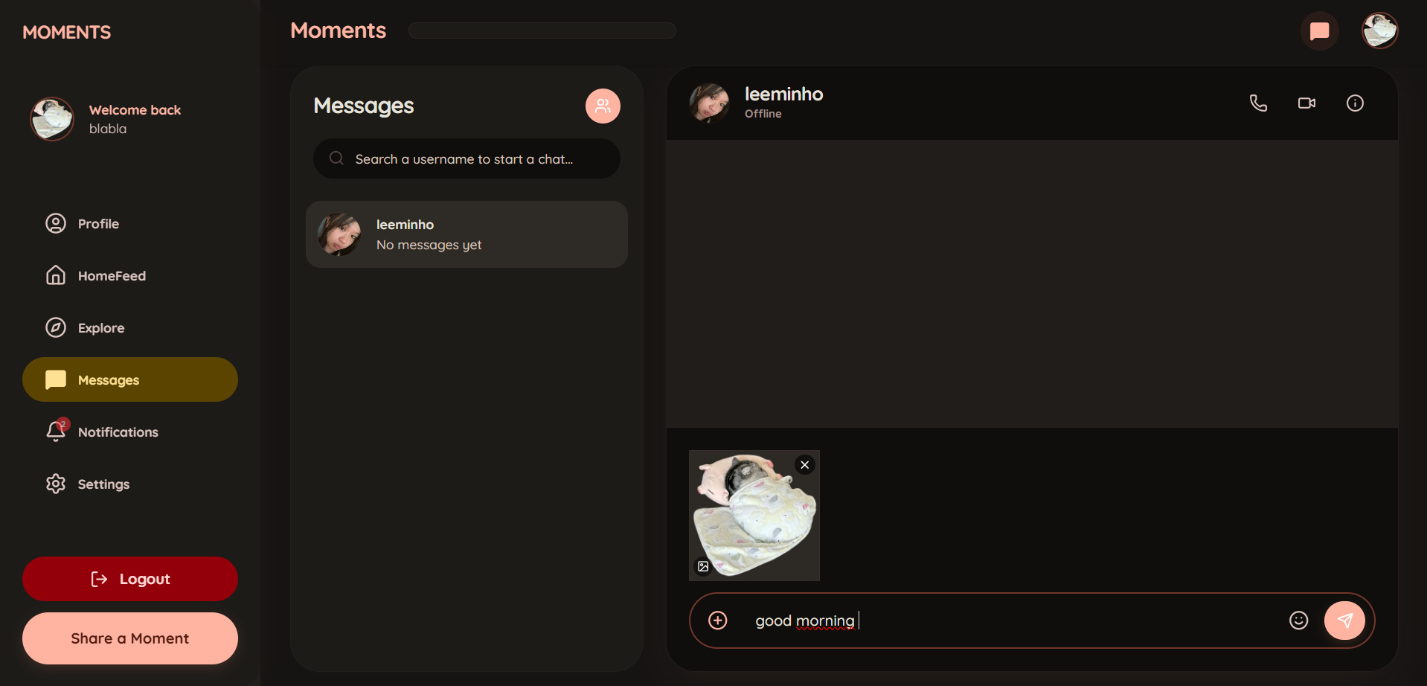
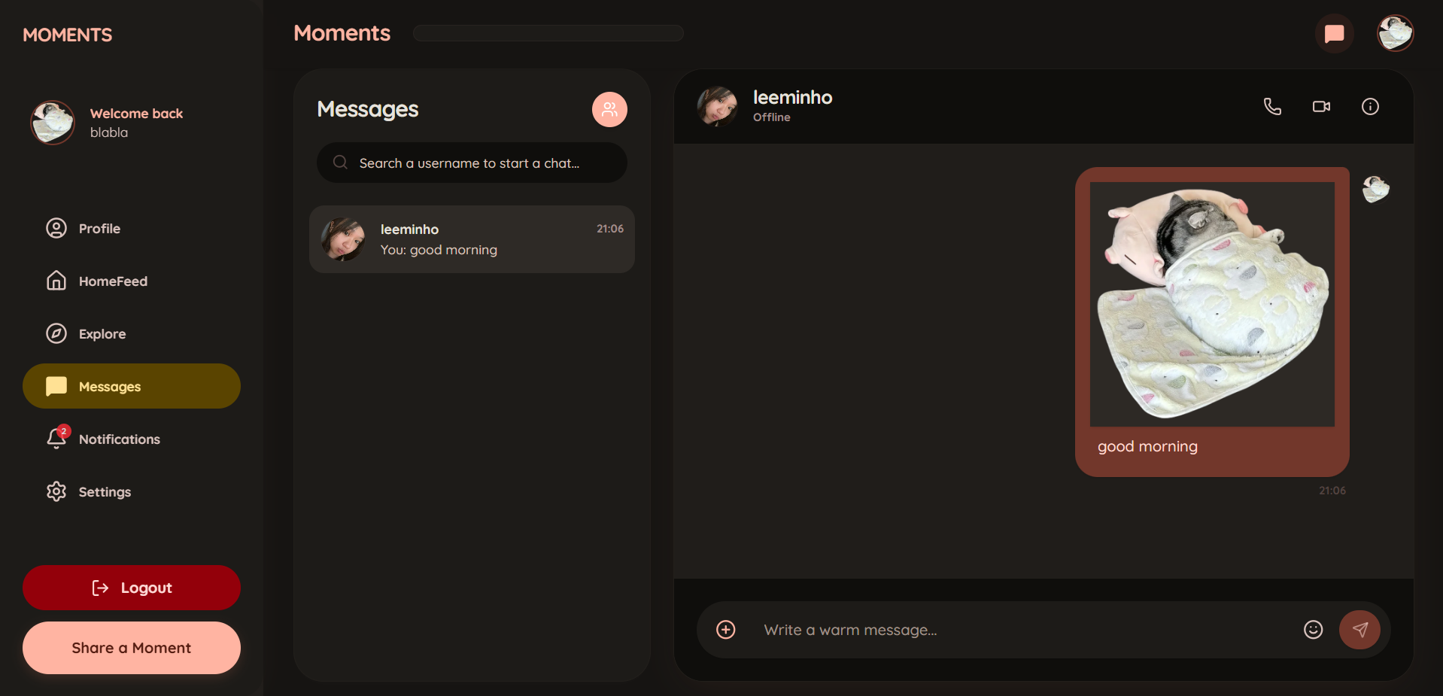
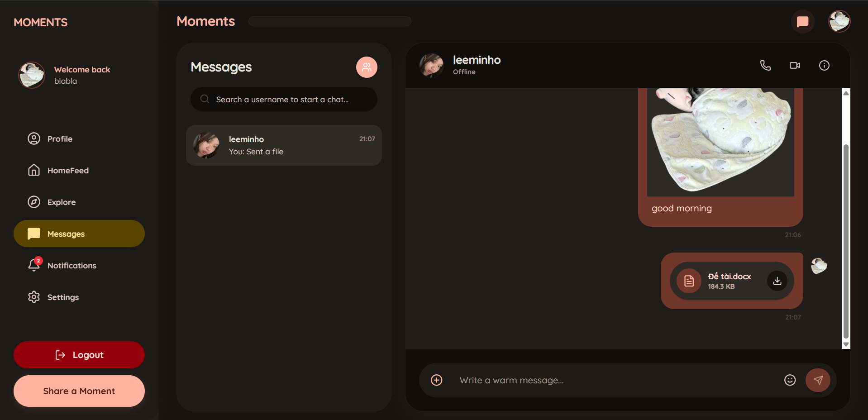

Chat shows a conversation list and active thread. WebSocket delivers messages and typing updates without refreshing the page, MongoDB persists conversation history, and Redis supports online presence. Attachments include images, videos, PDF, and DOCX files subject to upload controls. Direct conversations also provide access to one-to-one LiveKit video calls.

One-to-One Video Call with LiveKit
Users can start a private one-to-one video call by selecting the video icon in a direct conversation. The outgoing screen displays the recipient and ringing status, while the incoming screen provides Accept and Decline actions. After acceptance, LiveKit carries real-time audio and video. The interface shows the other participant, a local camera preview, call duration, and controls for the microphone, camera, and ending the call. Chat Service manages call permissions and state, while WebSocket signaling synchronizes updates between both participants. The system records a call summary in the conversation and displays the final status for ended, cancelled, declined, missed, or disconnected calls. Users can select Back to chat to continue messaging.
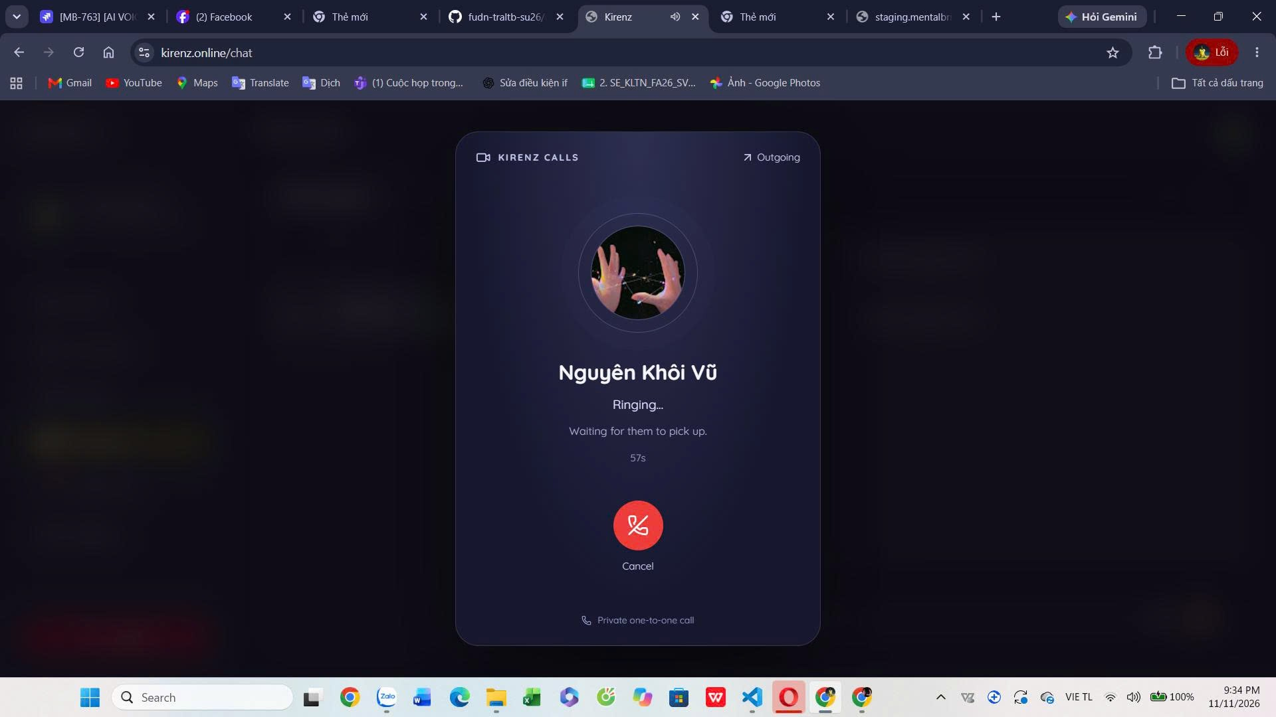

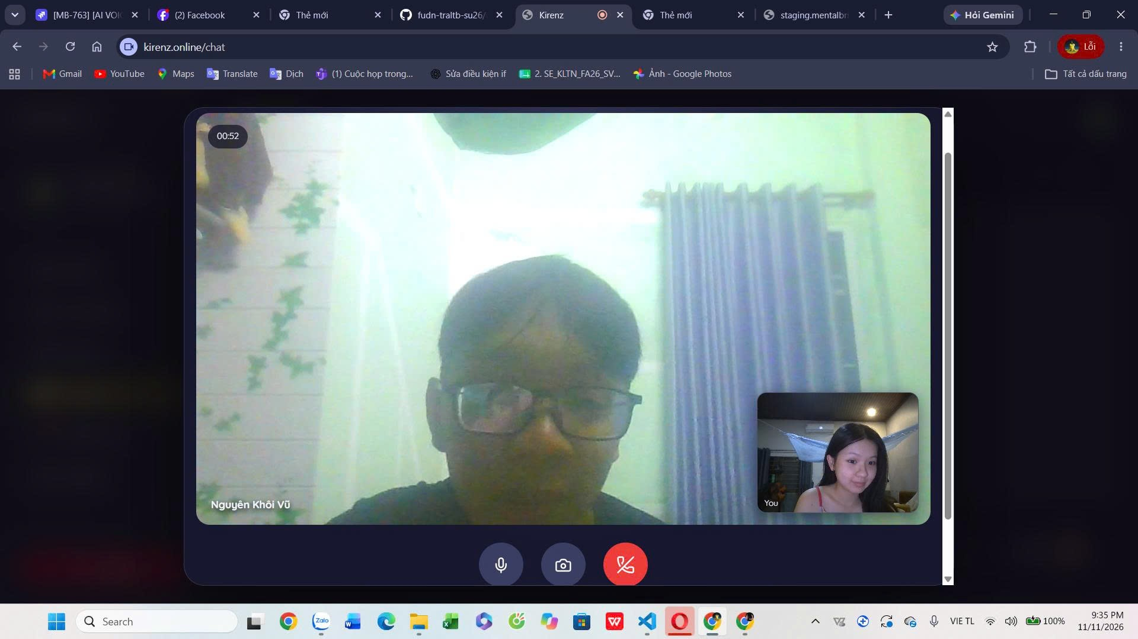

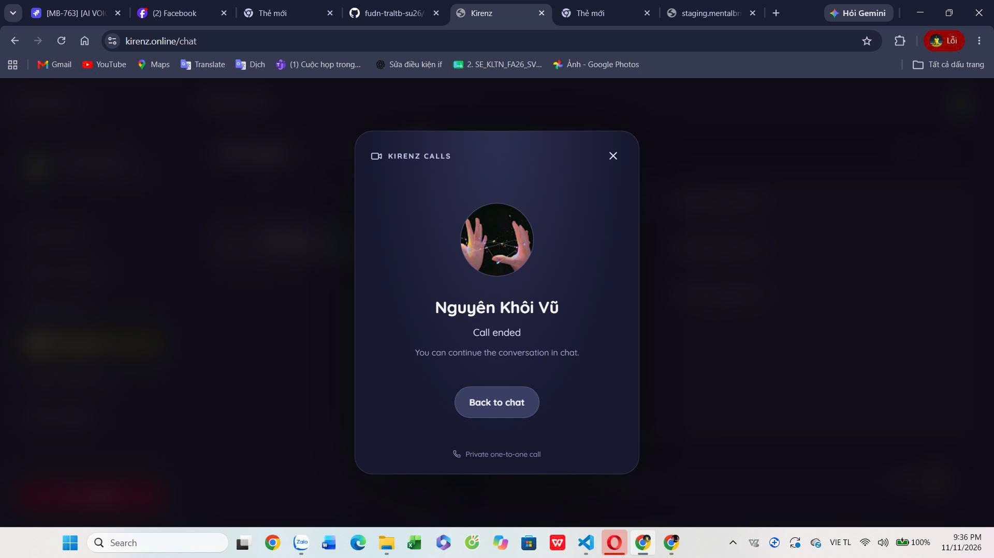

Group Chat Management

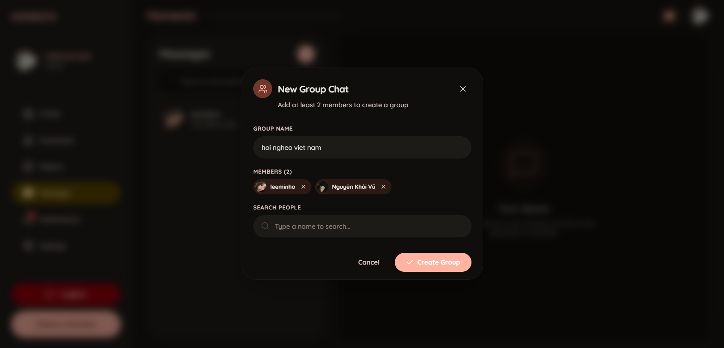

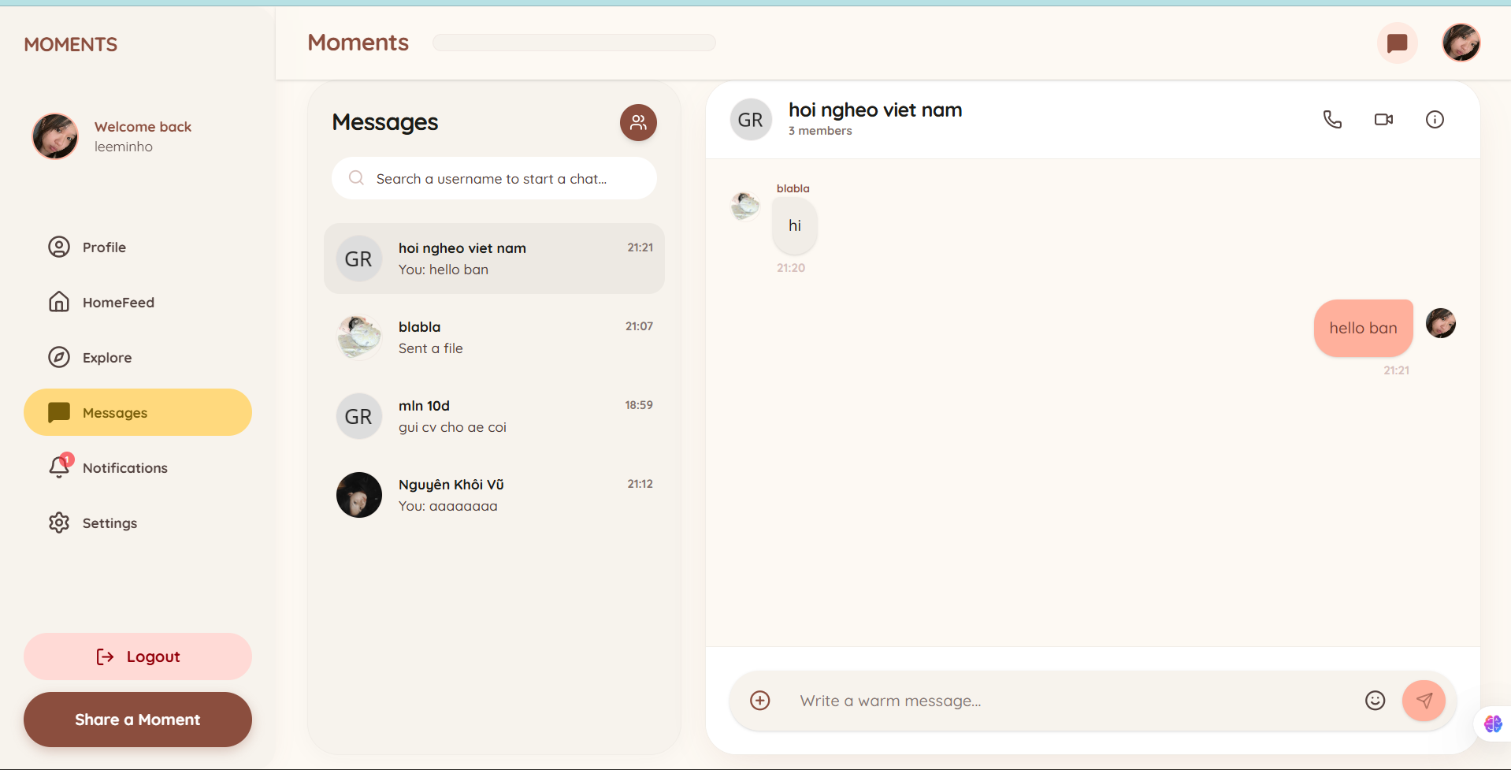

Authorized users can create a group, add/remove participants, promote administrators, rename the group, and assign nicknames. Permission checks prevent ordinary members from restricted operations.

Notifications

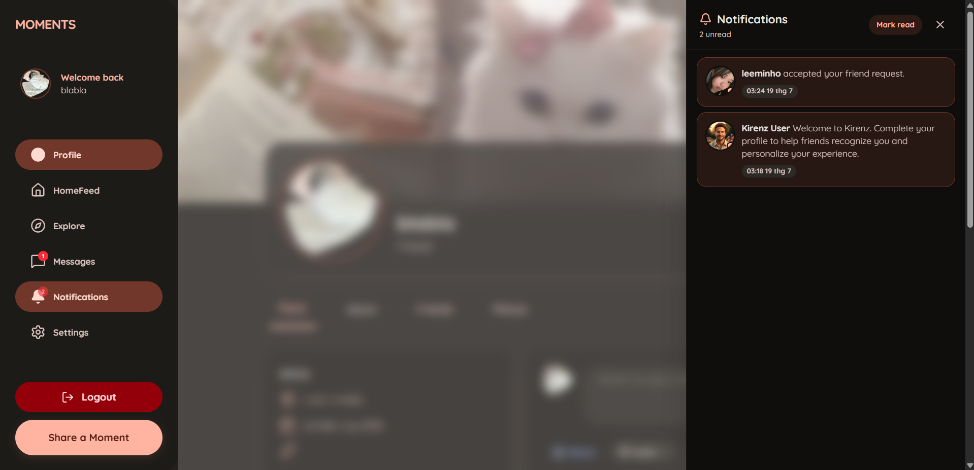

Notification Service consumes events, persists recipient history, and pushes updates to connected clients. The UI displays the unread count, supports individual and read-all actions, and opens related content. Administrative warnings, suspensions, and bans can link to a moderation notice containing the reason, issue time, notification message, and evidence when provided.
Moderation Notice
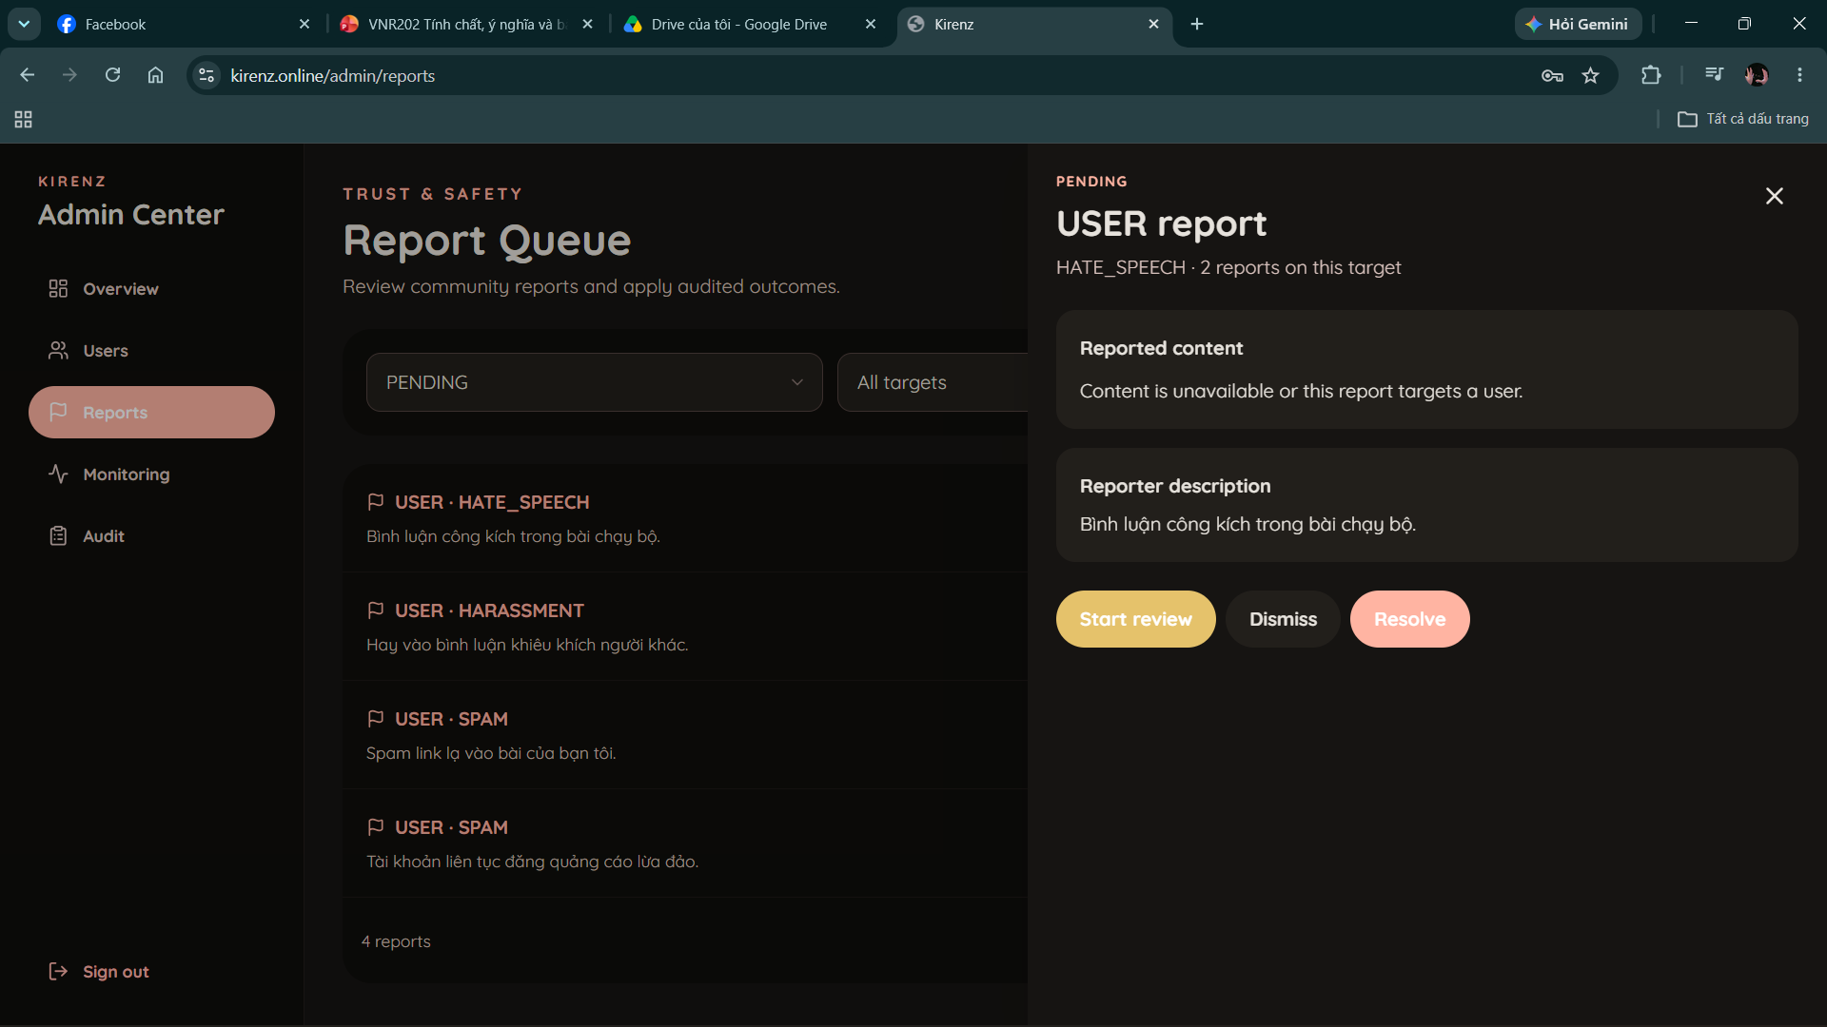
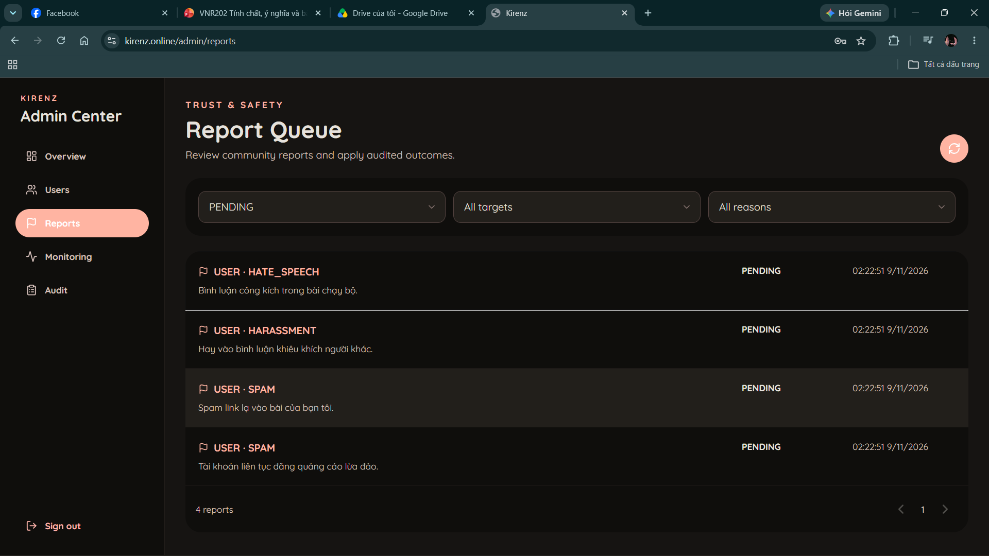
Administrative warning, suspension, and ban notifications can open a dedicated moderation notice. The page displays the action, issue time, moderation reason, notification message, and an evidence image when available. This allows the affected user to understand the account action and identify the notice when contacting platform support.

Admin features

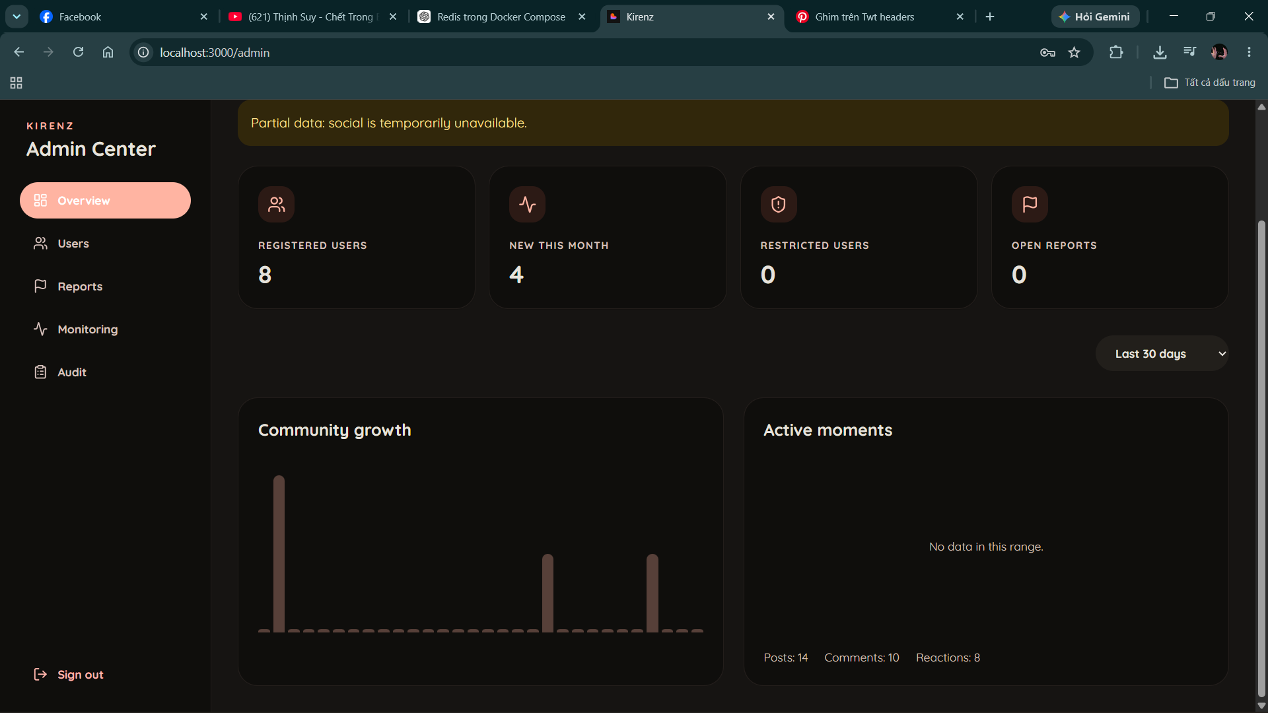

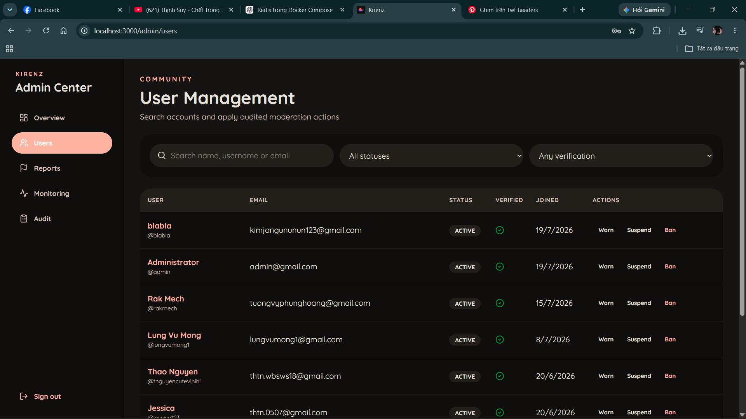

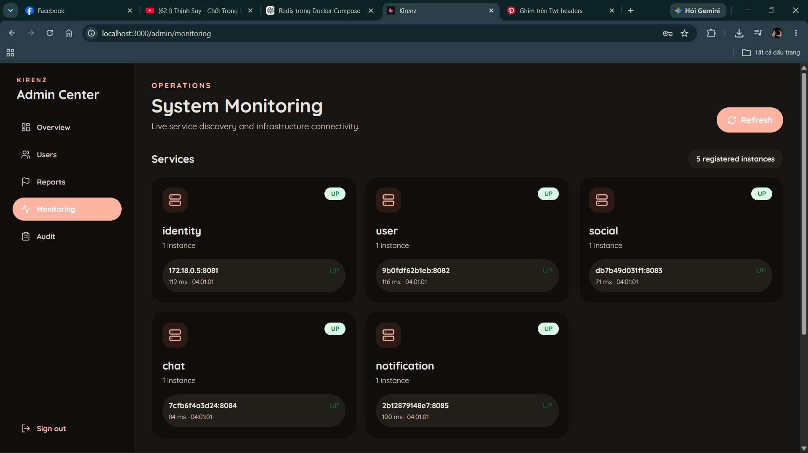

The administrator interface provides an overview dashboard, user management, report review and resolution, service monitoring, and audit history. Administrators can search users by keyword, filter by account and email-verification status, and warn, suspend, ban, or unban eligible accounts. Report moderation supports reviewing target content, hiding or removing posts/comments, applying account actions, and recording reasons and notes. Monitoring shows service health, discovered instances, response latency, and Kafka/Redis connectivity.
The administration interface is organized into Overview, Users, Reports, Monitoring, and Audit. The Reports and Audit views provide the detailed workflows described below.
Admin Report Review and Resolution
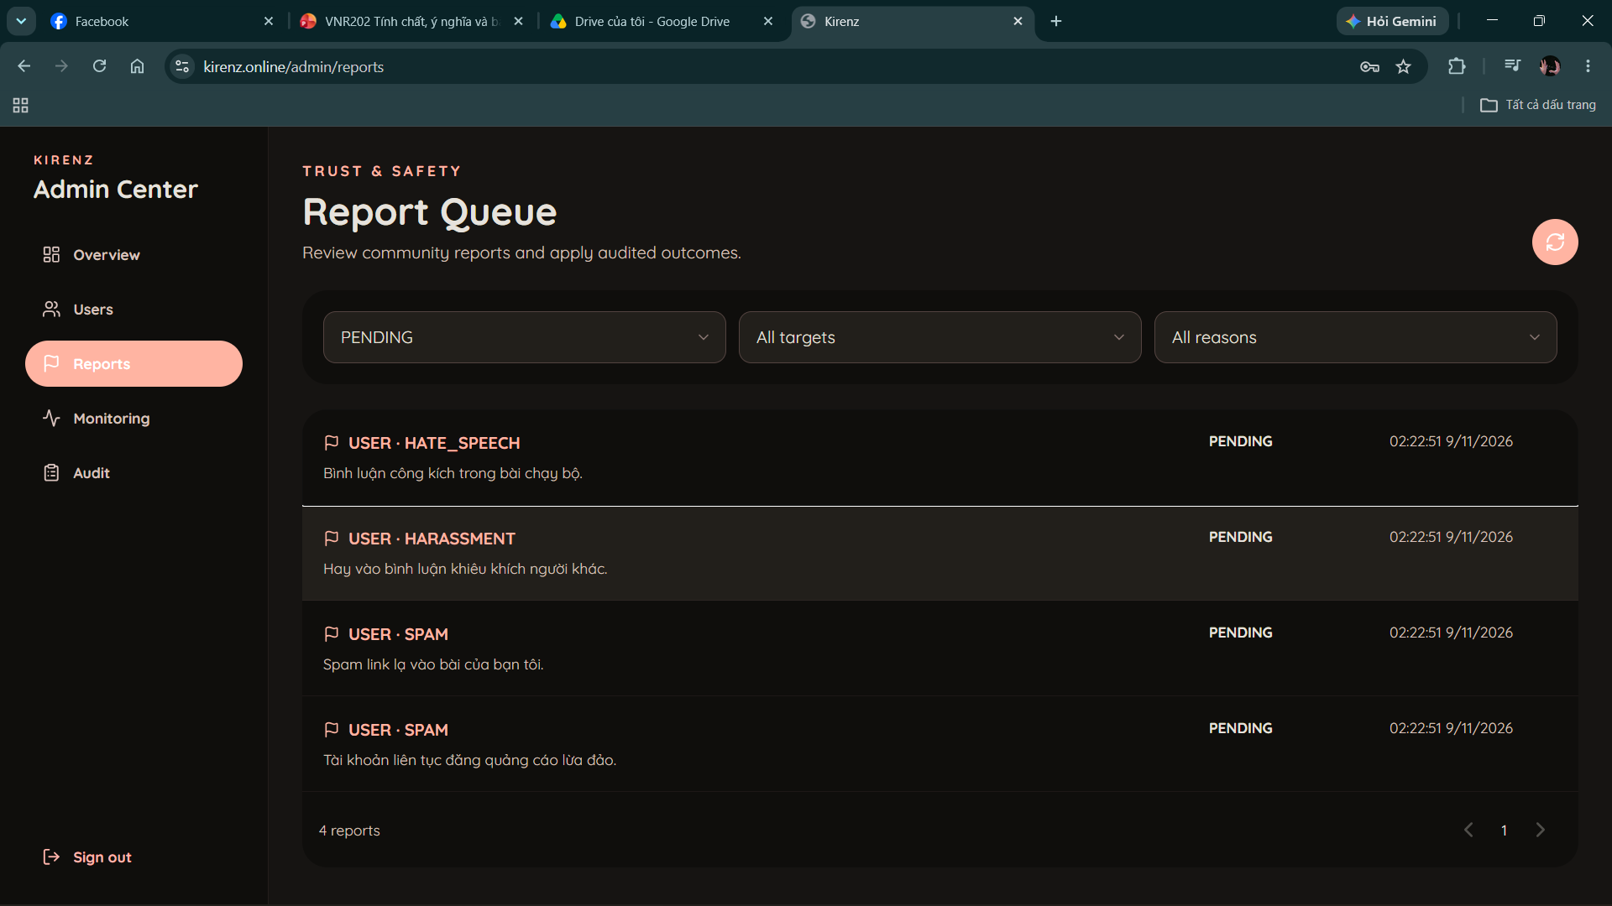
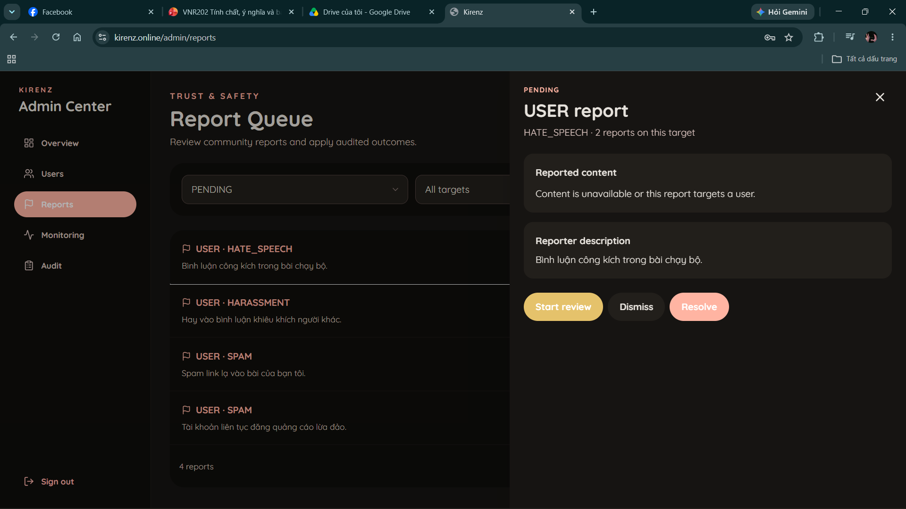
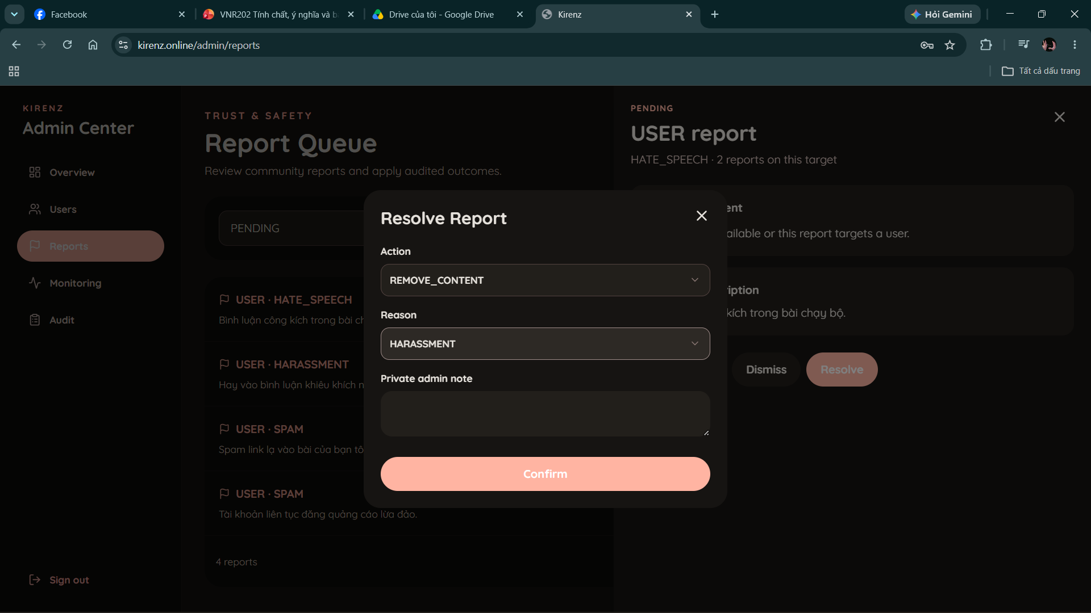
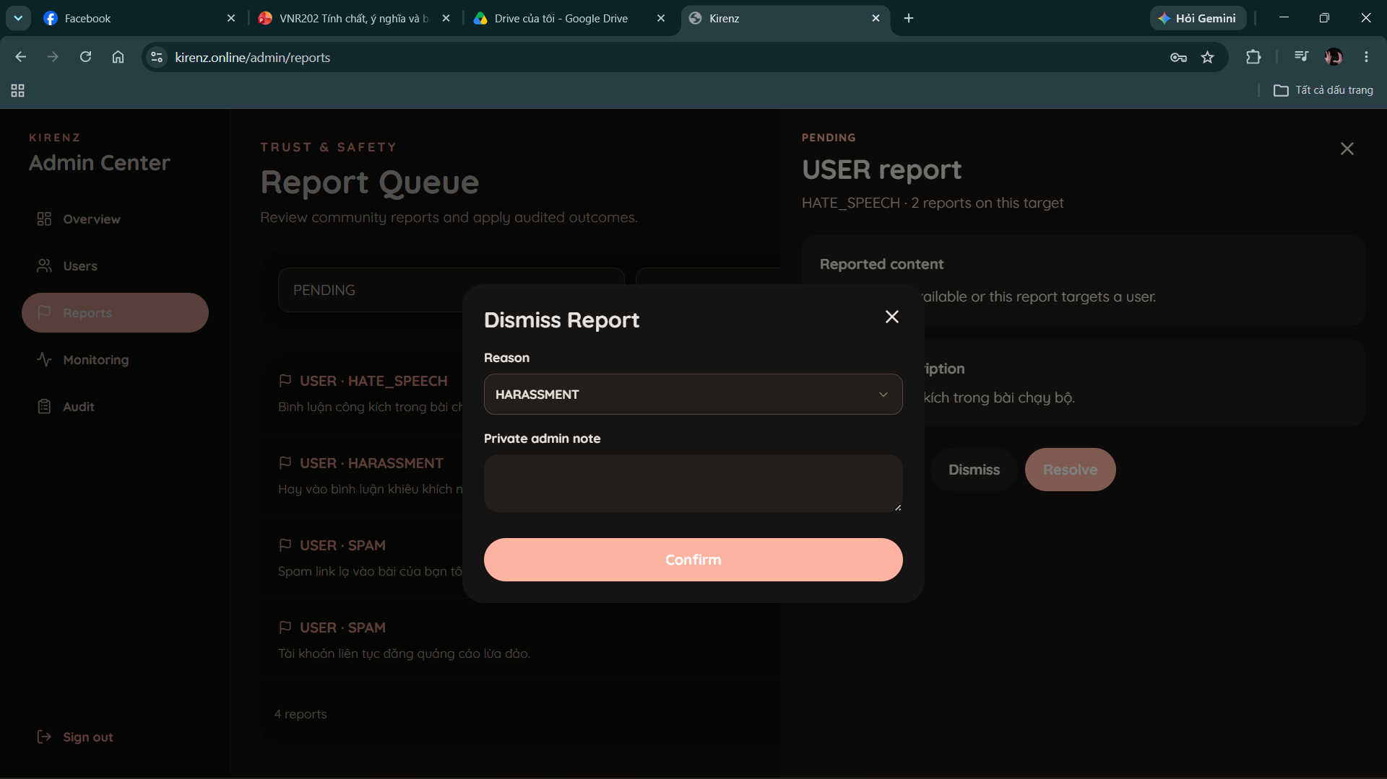
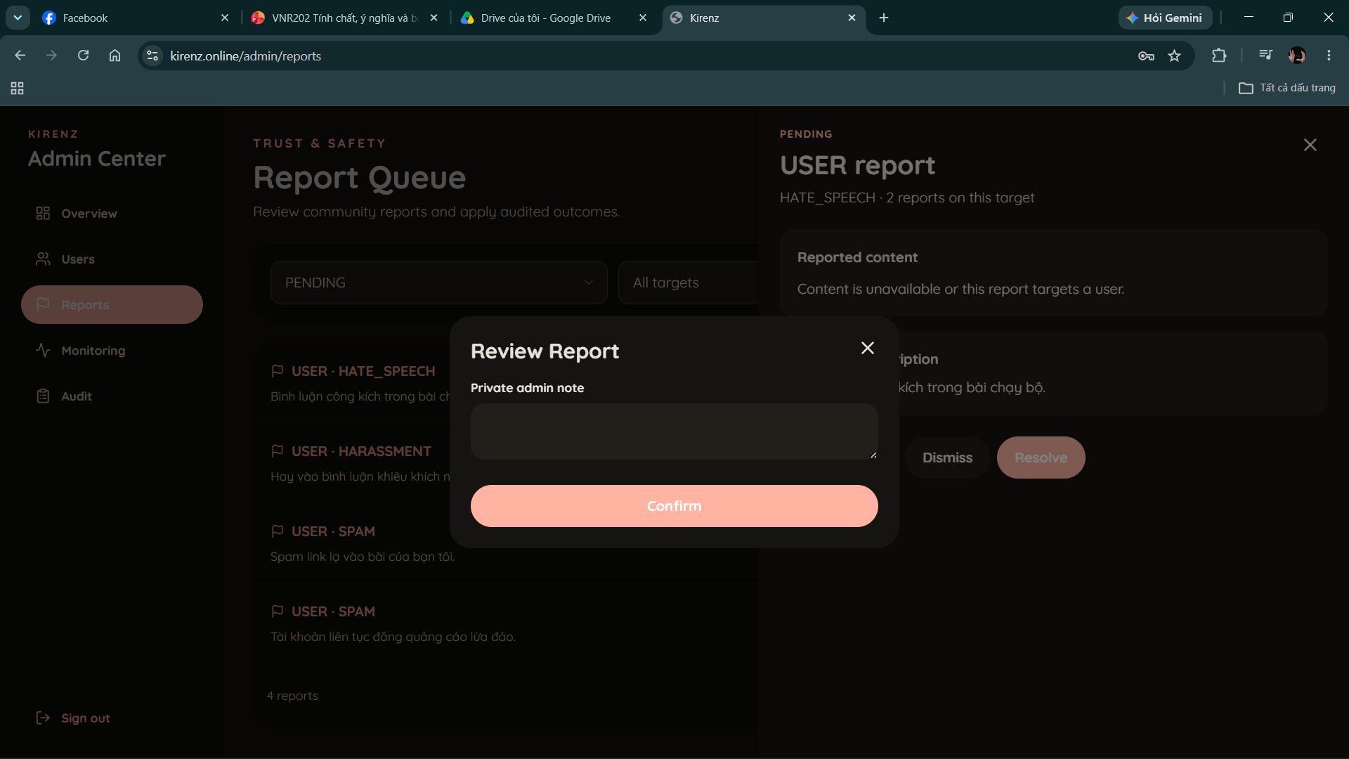

The Reports page displays a paginated queue that administrators can filter by status, target type, and reason. Report details show the submitted description, available target content, and the number of reports concerning the same target. An administrator can start a review, dismiss a report, or resolve it with a permitted content or account action. Moderation reasons, optional private notes, and suspension end times are captured as required by the selected operation.
Administrative Audit History
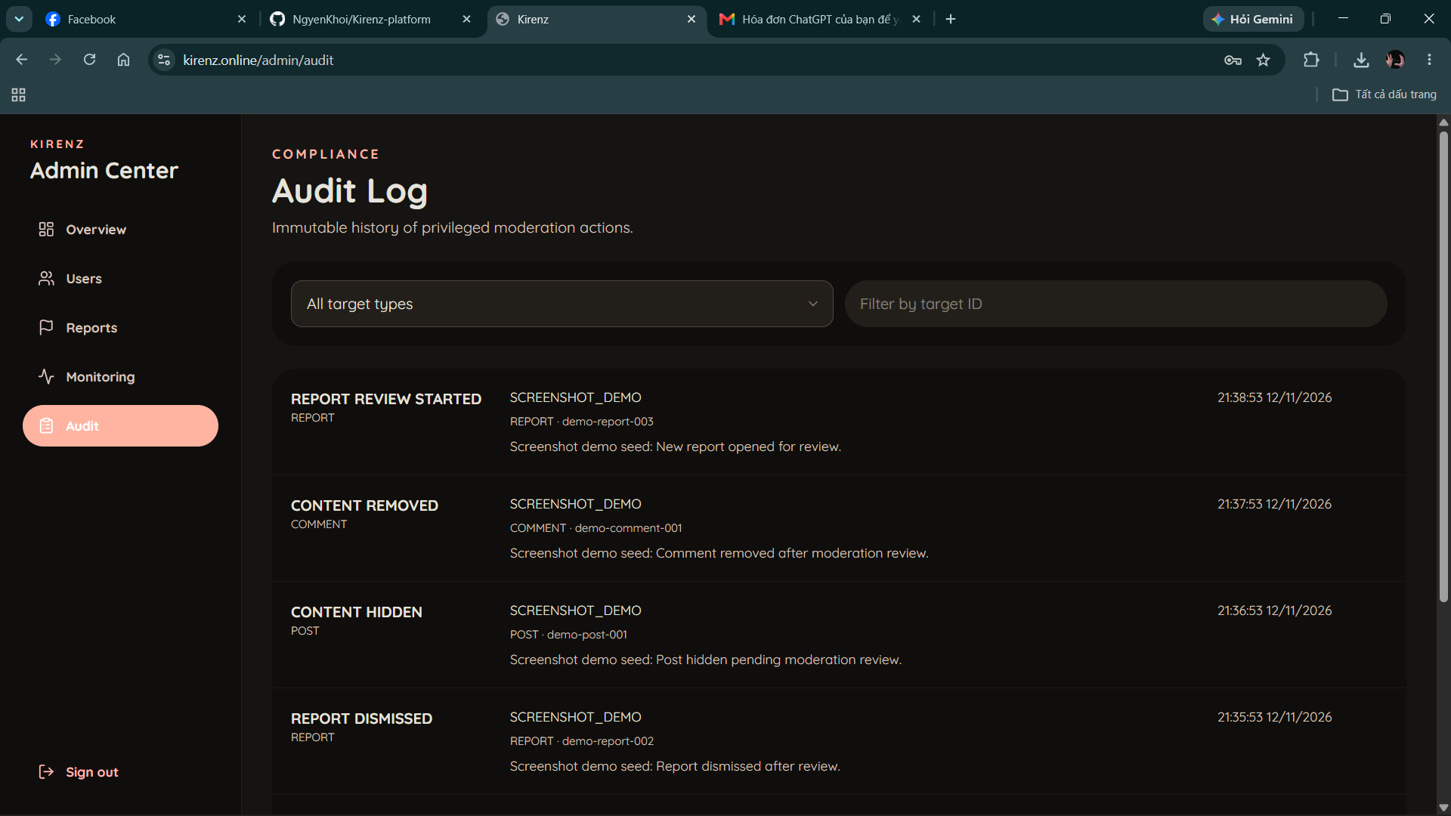
The Audit page presents a paginated history of moderation actions, including action type, target, reason, optional note, and time. Administrators can filter by target type and target ID. User targets are displayed with available account information, helping administrators trace the decisions applied to a particular account or reported item.

5. Conclusion
Kirenz Platform – Moments Social Network satisfies the MSS301 objective of building a meaningful Spring Boot microservices application. The project separates eight deployable Spring components around clear responsibilities, gives each business service ownership of its data, secures application traffic with JWT and Spring Security, combines REST with WebSocket communication, and uses Kafka for asynchronous integration. The React/TypeScript frontend demonstrates identity, profiles, social relationships, content, direct/group messaging, privacy, notifications, community reports, administration, and LiveKit one-to-one video calling.

Its main strength is the match between domain and technology: PostgreSQL protects relational invariants, MongoDB handles flexible social, chat, and call-session documents, Redis supports temporary state and coordination, Cloudinary hosts uploaded media, and LiveKit carries audio and video. Future work includes automated CI/CD, complete database container provisioning, centralized observability, improved event idempotency and dead-letter handling, expanded moderation capabilities, and broader end-to-end and performance tests. These additions can preserve the established service boundaries.

